

**T.I.M. “Time is money”**

**Employee Monitoring/Time Management Software**



**May 4, 2019**

**comp-226 scott smith, eric garcia, chris joyce, john carroll, samantha moss**

**Project Summary**

**Description of the Project**

Strong businesses rely on a keen sense of time and employee management. Many do not have the proper resources to precisely monitor the efficiency of each and every employee’s task completion and overall time spent working. This can lead to many issues involving lack of productivity, as well as overspending on employees. Our system T.I.M. (Time is Money), wholly captures and records employee data and information to track work efficiency and manage time. Companies willing to use this system can retain a strong hold on employee hour-management/hour-restriction, greatly reducing the over-expense on overtime and job burnout, and provide solutions for more flexible scheduling. Utilizing a silent or open monitoring system with live access to any employee on the network, companies can make sure these workers are actually doing what they are paid to be doing! (Not catching the highlights of last night’s game on YouTube.) Any business looking to keep an eye open while managing its network of employees, of any size, can leave worry behind with the support of T.I.M.

**System Capabilities**

The system should be capable of:

* Collecting and storing business and employee information
* Collecting and storing business expense
* Hierarchy of access to stored information and features (Managerial positions vs. employee access); Mobile access
* A user-friendly and customizable interface to better suit a majority
* An active and up-to-date database tracking system
* Silent or open monitoring
* Recorded hours of employees per week and hour limiting system
* Employee website tracking
* Will fully track proficient employees task completion, opening the possibility for more flexible scheduling
* Great for companies looking to allow workers to telecommute

**Who does it serve?**

The system is being developed to serve businesses, although it can be adapted to serve any productive environment. Given the system’s in-depth flexibility, T.I.M. can be used for a variety of purposes. Our service can be adapted to provide logistic information for school systems or any other network requiring close monitoring on member involvement, activity, and time contribution. Its purpose will be beneficial to any company that wants to save money and know that they are getting what they pay out of an employee.

**Why would anyone want to use it?**

This system will optimize how time is being used and allocated on all ends of the employee hierarchy. T.I.M. provides data on employee work habits that can help employers increase workplace efficiency, allot time more accurately, and reduce the over-expense on unapproved overtime hours.

**Anticipated business benefits?**

* Monitor overall spending, hours spent working, task completion
* Healthier work environment for employees
* Allow more accuracy in time allotment; develop better customer repertoire
* Save the company money by being able to track employee work and limit after hours work
* Employees working too much overtime can actually lead to less productivity

overall

* Use of tracking can also find websites users are browsing that they should not and outsource that URL to have blocked.

**Requirements**

Essential

* Terms of use and consent disclaimer for open monitoring system will be presented at login. Certain locations and may require this for legal reasons.
* User-friendly, customizable interface. This will include features allowing users to organize the look/layout of the system, establish a workplace hierarchy to enforce separation of duty, and choose exactly what data/features can be displayed and accessed. Levels of access to privileged actions and information will vary depending on user role in the hierarchy. A user in a managerial position will be allowed more freedom to work within the system than an employee.
* System provides each employee with a unique username and password required to access and use T.I.M. monitored computers. This system allows user data to be tied to its respective employee.
* A login page that requests valid employee credentials. If a user login or password is not verified within the respective system, send an error to user. Users who have forgotten their password will have the option to request a new password.
* Organizes employee tasks and monitors employee task completion to provide statistics on workplace productivity.
* System should track each employee’s total time spent working. Users will have the option to customize this feature for totals, different pay periods, projects, or any other required time determinations.
* T.I.M will implement live database tracking. The database will actively store business and employee statistics and other logistic information. The system will also store and provide access to online activity of users within the network. - - Managers and other privileged users can use this information to monitor and restrict web activity.

Important

* Silent or open monitoring. Many regions may require a disclaimer for the monitoring system. Silent monitoring can be implemented for areas that do not require this. Managerial positions will have the only access to this feature.
* Secure employee/employer information
* User/system transparency (understand terms of use)
* User data encryption for PII (personally identifiable information), any information being input that deals with PII (date of birth, address, birthplace, etc.) will be encrypted using SHA-256, any passwords will be encrypted with AES-256 bit encryption or some form of those two.
* Research and outsource to vendors for cloud-based/physical database storage system per organization requirements.
* A customer service or FAQ application to help users get accustomed to utilizing the system to its full ability

Nice

* Keystroke monitoring
* Request access log (support ticket)
* Automated Employee Invoice (report) of user activity/time log
* Automated updating system, using background resources.
* Auto-boot software on all machines on the network. Upon network access, T.I.M. will display an alert to the user to show the system is active and request user login.
* Messaging system for interfacing between worker’s network
* International language support to reach as many clients as possible.
* Live chat for support

**Functional**

* Consent disclaimer for open monitoring (legal reasons). When the user logs on, a prompt appears stating that the individual is being monitored on what he or she searches and does. User must select the “Okay/Agree to terms” button to continue using a device on the T.I.M. monitored network.
* User-friendly, customizable interface. Implement an initial setup guide to assist companies in customizing the system to their needs. Layout and feature organization based on specific hierarchy needs can be established here. At any time, users with managerial privileges can access this application to further adapt the system to any required changes.
* Each user of the system will be given a User ID#, as well as an initial password. This information is linked directly to the system’s database. Management with access to T.I.M.’s active database can view or edit any employee’s information following these specific User ID# keys.
* Database organizes tasks, actively tracks task completion, and stores a record of hours spent working. Based on these totals, develop algorithm to calculate levels of employee productivity.
* Database will actively track web usage from users within the network. This information can be accessed and edited by users with management privileges.
* Implement website restriction software to monitor and optimize web usage of users within the network.

**Usability**

* Clean and precise login screen. Simple enough for even the least tech-savvy of users.
* Upon being given a specific User ID# and password by the System Administrator, user will have the option to update/customize login name and password after initial login. Login names and passwords must follow specific system standards and protocol. (Ex. 8-15 characters long, UPPERCASE/lowercase, numbers, symbols, etc.)
* Simple infographics to display performance of user while system is active.
* Each pay period an employee can have their own portfolio displayed to a supervisor upon request through a button detailed “Employee Report.” This will output specifically the employee’s current productivity and schedule.

**Reliability**

* System will require 24/7 access with limited downtime to ensure a productive and functioning workplace at all hours.
* Five nines of availability, making sure we have the most up keep time for performance and security.
* Live support chat, FAQ application, and a customer service phone line

**Performance**

* Real-time monitoring. Management doesn’t want to learn ten minutes later that restricted websites are trying to be accessed.
* Auto-update system using minimal resources

**Security**

* Employee information protection. User data encryption for PII (personally identifiable information), any information being input that deals with PII (date of birth, address, birthplace, etc.) will be encrypted using SHA-256, any passwords will be encrypted with AES-256 bit encryption.
* Outsource to vendors for cloud-based/physical database storage system per organization requirements.

**User Case Stories**

* As a business manager/owner I want to optimize the production of my business and it’s employees as efficiently as possible throughout the work day.

**Acceptance Criteria:**

1. Be able to monitor and restrict employee web usage.
2. Keep a record of all employee hours.
3. Be able to approve employee hour submissions and unique pay periods.
4. Organized and secure process for payroll transfers.
5. Produce Employee Reports at any given time.

* As an employee, I want to manage my hours and check my work schedule in a clear and convenient manner.

**Acceptance Criteria:**

1. Simple, intuitive GUI interface.
2. Organize all tasks (In Progress, Completed, and Not Yet Started)
3. Allow control to input hour submissions for management approval.
4. Show a history of logged hours, as well as logged work history in a readable calendar format.
5. Allow communication with co-workers and management using a built-in messaging system.

* As a company administrator, I want to manage and optimize my business in a straightforward and transparent fashion.

**Acceptance Criteria:**

1. Allow access to all user accounts on the network for optimal monitoring.
2. Include a simple application for implementing custom features/accessibility into the company UI.
3. Grant the ability to create/edit/delete user account information for company control.
4. Be able to monitor and restrict web usage of all users on the network.
5. Produce and store scheduled system backups in case of emergency.
6. Have a customizable help application to further assist all users on the network.

* As a system administrator, I want to ensure T.I.M.’s benefit to workplace efficiency through collected statistics as safely and informatively as possible.

**Acceptance Criteria:**

1. Store and protect all critical company information.
2. Store all information of user productivity for statistical insight to workplace efficiency. (Benefits system updates and growth during its life cycle)
3. Produce, store, and grant access to system backups in case of emergency.
4. Grant remote access into the system and its users.

* As a live support admin, my goal is to assure business managers have the best possible experience with T.I.M. simply and quickly.

**Acceptance Criteria:**

1. Grant remote access to the system’s users.
2. Store and provide contact information for system support admins for quick and easy help connections.
3. Include an intuitive messaging system to allow simple, real-time support with system users.

**Users**

1. Management
2. Company Administrator
3. Employee
4. System Administrator
5. Live Support Representative

**User Goals**

**Management**

* Monitor and evaluate certain web sites to curb improper use of time and equipment by employees
* Decide on the aesthetic of the system for company needs
* Be able to keep track of hours and approve of hour submissions for all employees
* Obtain Employee Portfolios (Employee Report) at any time
* Oversee and direct payment of employees to company payroll system
* Authorize unique pay periods to payroll transfer: Pay by project completion, pay upon set time total, other time determinations
* Real-time interaction capability.

**Company Admin**

* Monitor overtime and overall employee work hours
* Using the system’s user-friendly interface, implement the aesthetic of the system with management approval
* Interact with the system to edit/update employee information
* Be proficient enough with the system to oversee and enforce website restriction
* Retrieve system backup in a critical situation
* Create/authorize new user profiles for new employees
* Edit/update company help system to increase usability (FAQ)
* Real-time interaction capability.

**Employee**

* Input overtime/work hours to be validated by management
* Log in to T.I.M. via username & password
* Check work schedule
* Organize tasks and monitor task completion
* Create/customize user account credentials following system standards and company protocol (edit username/request a new password)
* Conveniently communicate with other users on the network using internal messaging system.
* Real-time interaction capability.

**System Admin**

* Oversee the security and functionality of the system
* If needed, boot recovery/backup data should the system crash at any time.
* Implement and deliver software updates as needed
* Complete remote access capabilities
* Real-time interaction capability.

**Live Support Representative**

* Remote access with a user to help internally.
* Live support chat with the client.
* Real-time interaction capability.

**Subsystems:**

Management Subsystem

**Management**, **Company Admin**

User Account Subsystem

**Employee**, **Company Admin**, **Management**

Support Subsystem

**System Admin**, **Live Support Representative**, **Company Admin**

**Management Subsystem**:

Have 24/7 real-time access to a complete roster of employees, employee hours, tasks, and task completion. **M C**

Obtain Employee Portfolio (Employee Report) at any given time. **M C**

Direct payment of employees to employee payroll system. **M**

Authorize unique pay periods for payroll transfer. **M**

Authorize employee hours and task completion. **M**

Authorize and assign new tasks to employees. **M**

Authorize or disapprove of overtime hours. **M**

Monitor and evaluate website usage to optimize employee productivity. **M C**

Enforce website restriction. **M C**

Customize and design the aesthetic of the system to apply to company needs. **M C**

Implement changes to the look of the system with management approval. **C**

Create/authorize/edit/update user account information for all levels of the business hierarchy. **C**

Real-time interaction capability. **M C**

**User Account Subsystem**:

Create a new business profile for use on a T.I.M. monitored network. **M C E**

Log in to a T.I.M. monitored network via username and password. **M C E**

Customize user account credentials following system protocol and company standards. **M C E**

Organize tasks and monitor task completion. **E**

Manually input work hours/overtime hours to be authorized by management. **E**

View new/upcoming tasks and develop optimal work schedule. **E**

Use internal messaging system to communicate with other employees on the network. **M C E**

Real-time interaction capability. **M C E**

**Support Subsystem**:

Oversee security and functionality of the system. **S**

Boot recovery/backup data should the system crash at any time. **S C**

Implement and deliver system updates readily. **S**

Complete remote access to the system and its users at any time. **S C**

Remote access to any user in the event of needed support. **S L C**

Engage in live support chat with users on the network. **S L C**

Implement and customize FAQ application to further assist users. **C**

Real-time interaction capability. **S L C**

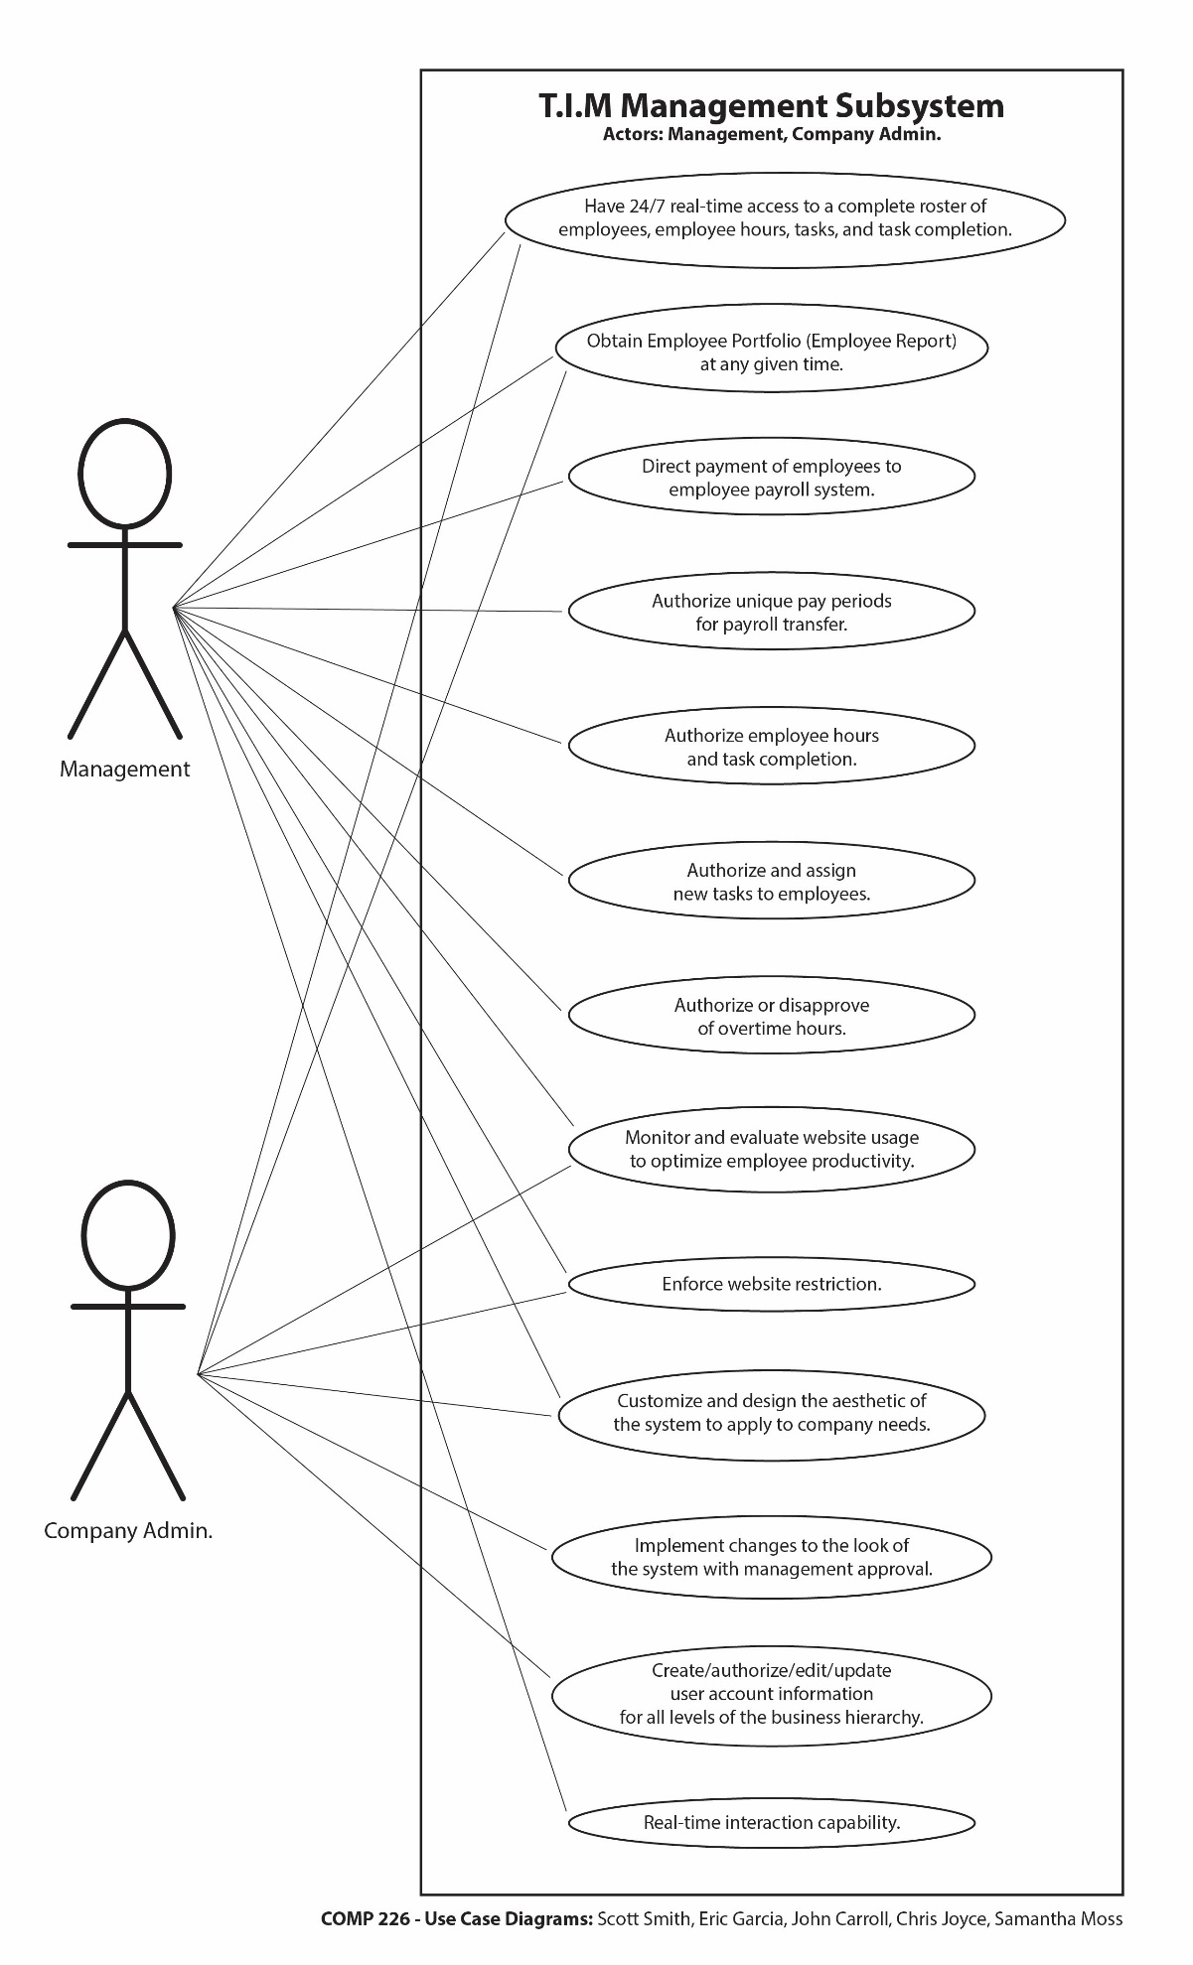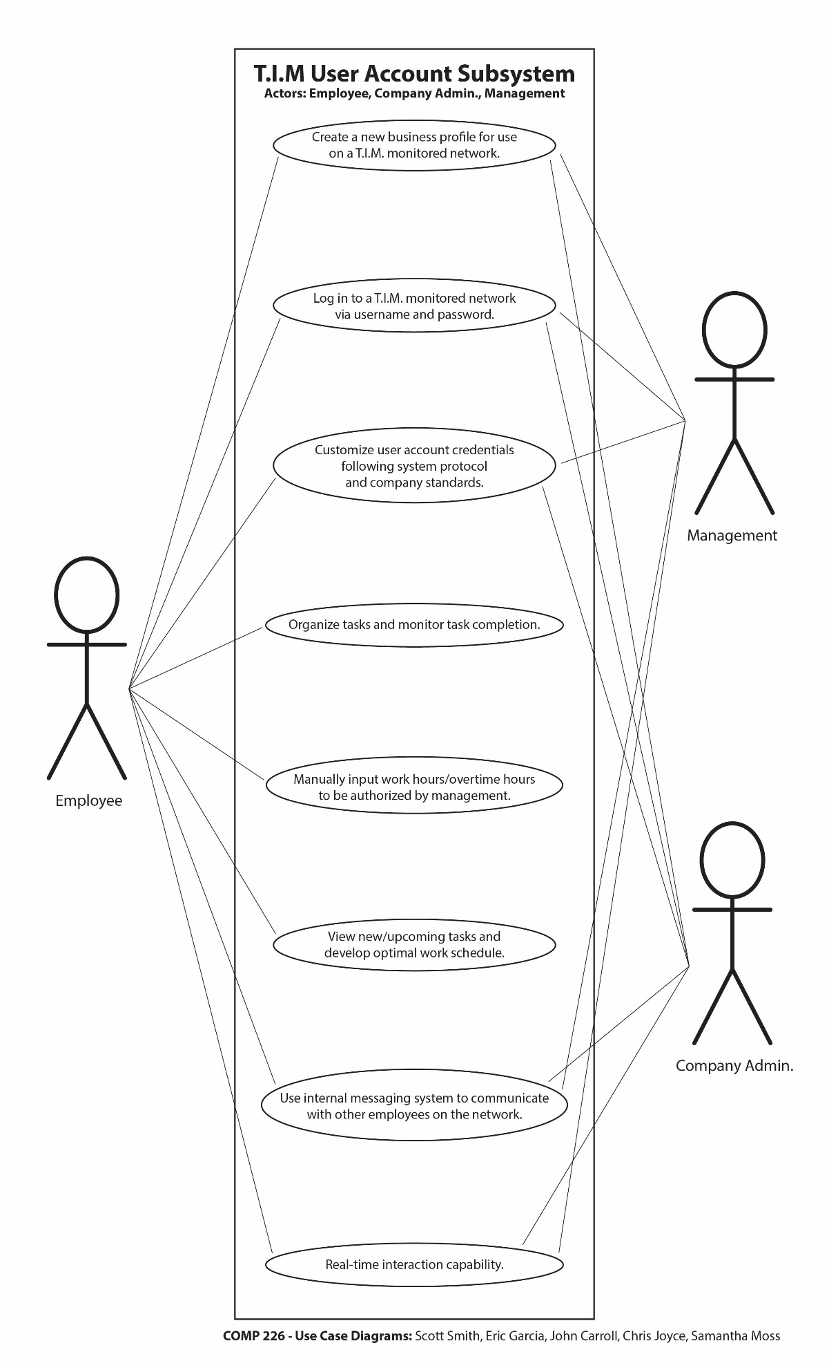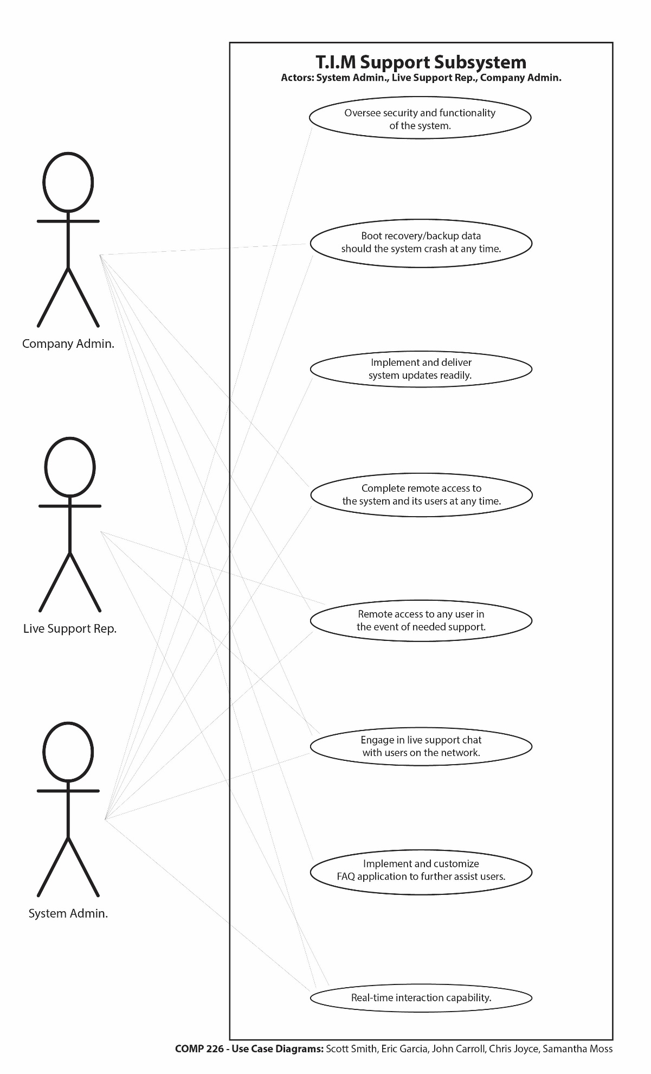

**Class Diagrams**

**For a T.I.M. monitored network**

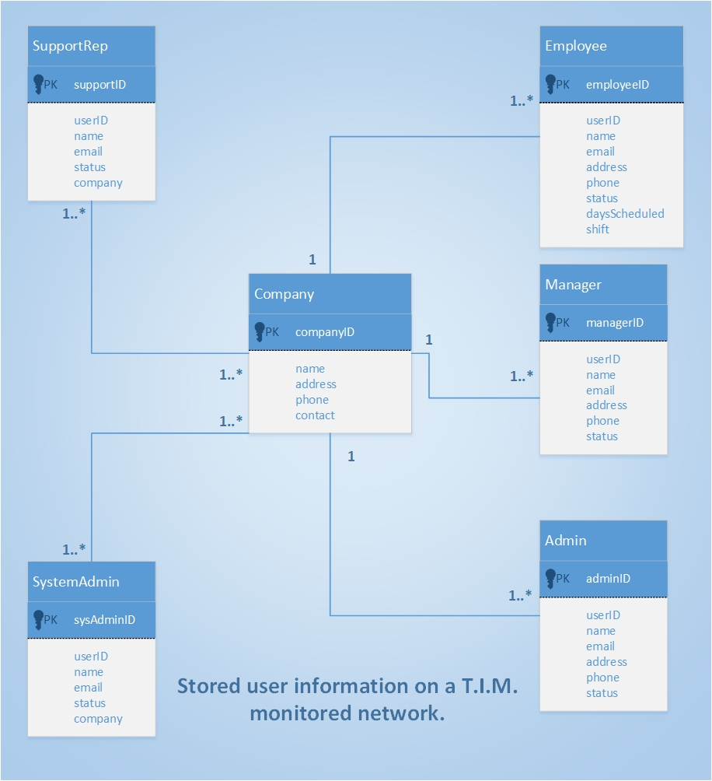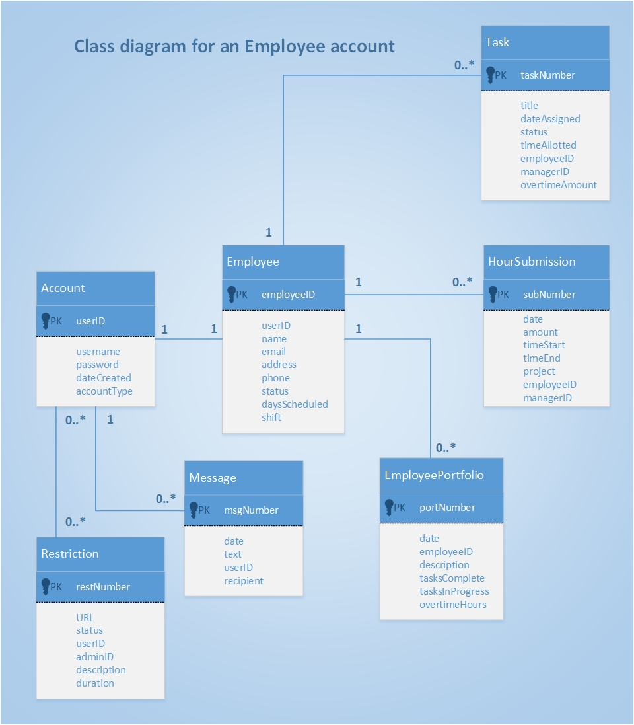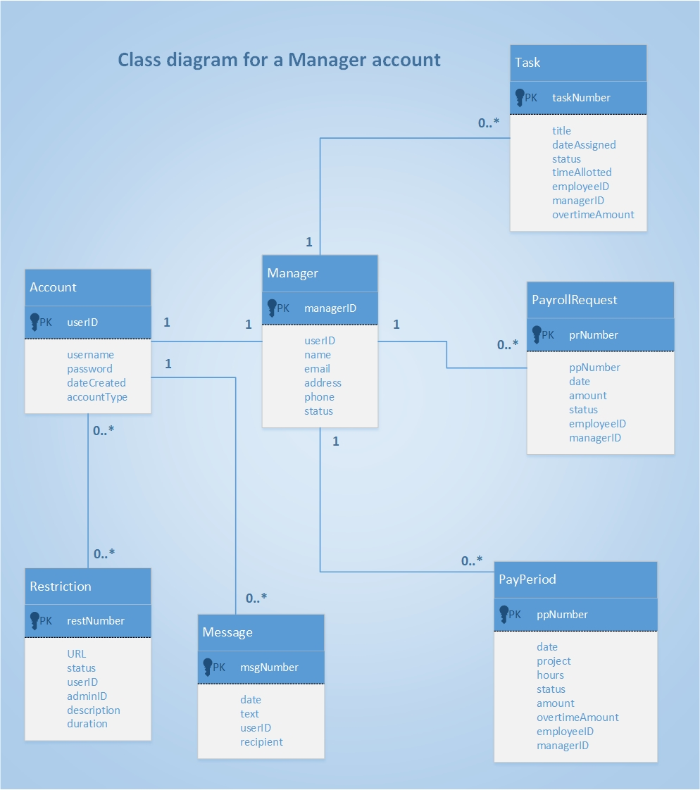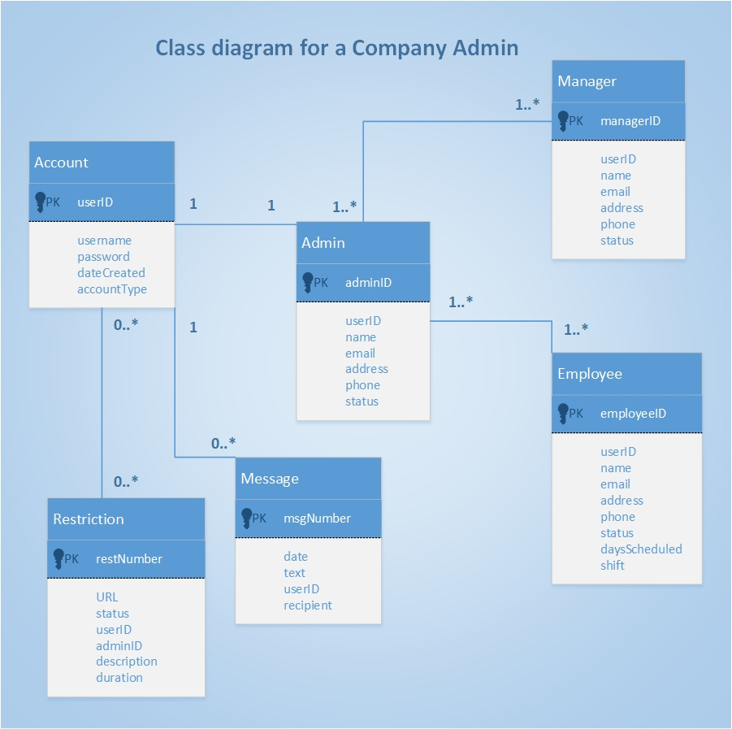

**System Sequence Diagrams**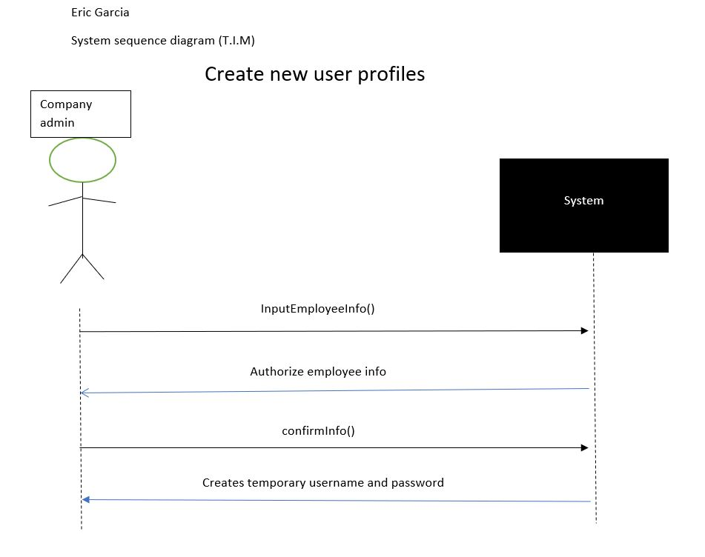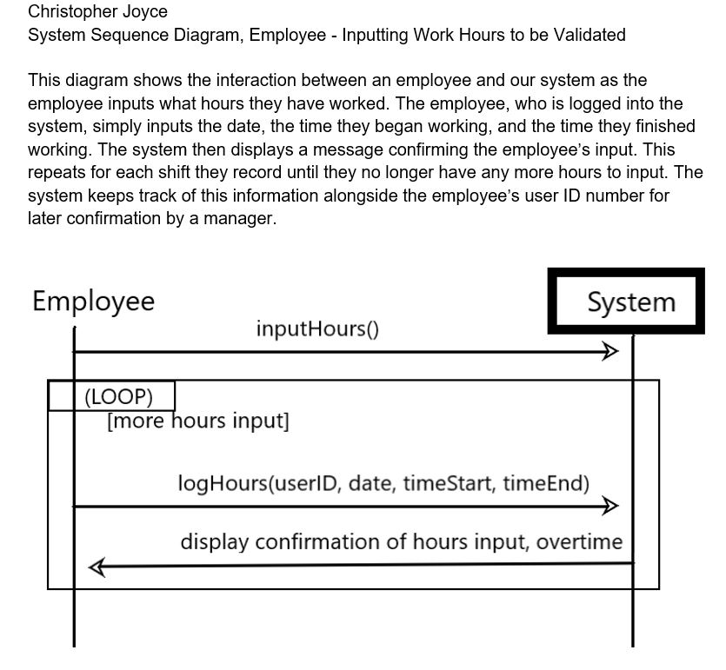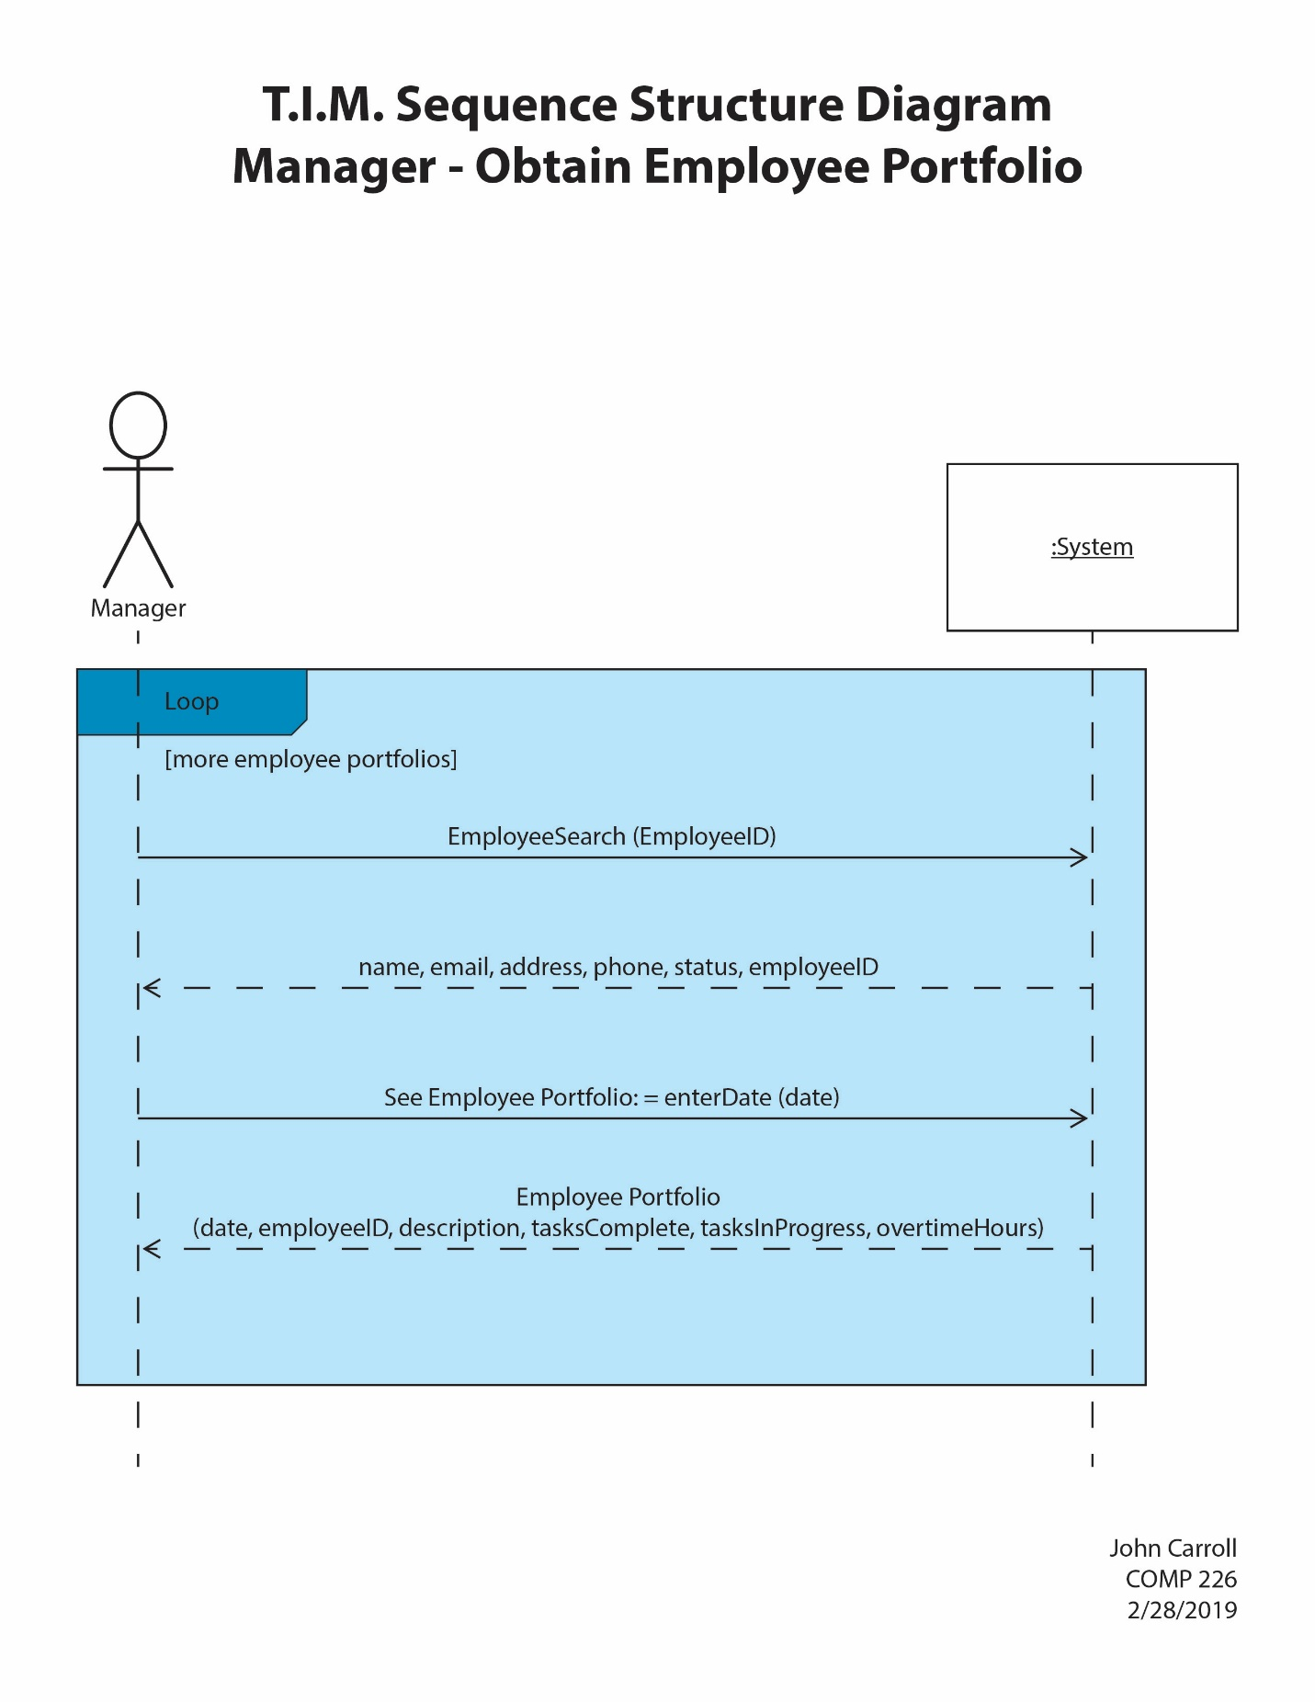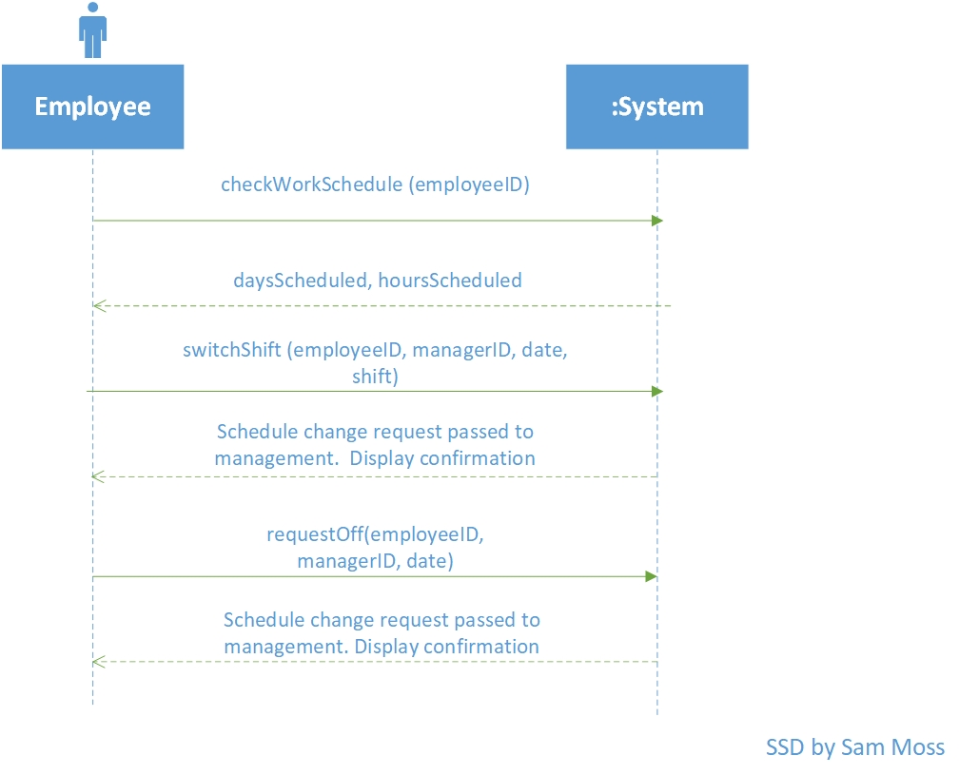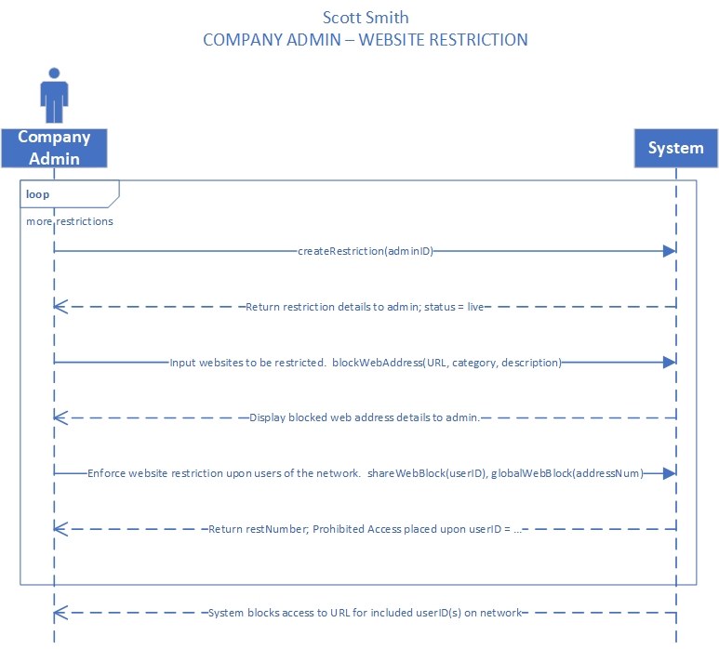



**APPLICATION CONTENTS**

**Scope and size – what are the functions, boundaries, interfaces?**

* The application must be large enough to contain a user-friendly/customizable and intuitive interface (GUI) as well as an optimized database with real-time access to tracked company information.
* Functions that must be included:

- Update/edit all attributes of a user account (updateName, updateAddress, updatePassword, ect.)

- Delete a user account

- Input website restrictions to block user access

- Input hours for approval by management

- Input and assign tasks

- Process unique pay periods

- Process approved hours for payroll transfer

- Process Employee Reports

- Check work schedule and monitor tasks

- Send messages between users of the system

- Allow remote access into the system

     - An important boundary will be defining a hierarchy of user access.  A company admin will have the privileges to access/edit/update all user account information, implement the design of the user interface, and validate website restrictions.  Employee accounts will be restricted to viewing a current schedule, monitoring new/in-progress tasks, and submitting hour submissions. A manager will have access to approving these hour submissions, processing unique pay periods, processing hour submissions for payroll transfer, and processing employee reports at any time.

**Programming language – what are the accepted languages?**

* The application will be programmed in an object-oriented format using Java.
* JavaFX will be used to configure the GUI.

**Build or buy – is an acceptable version available to purchase?**

* To achieve the correct design, feel, and look of T.I.M., our system will be built from scratch.

**How will you ensure:**

**Separation of duties:**

* Systems will be in place to order users of different roles in a kind of hierarchy. This hierarchy is structured to fit its respective workplace environment and will provide different levels of information and permissions depending on user rank in the hierarchy.

**Auditing:**

* Unique user ID #’s will be given to every user on the network, including System Administrators and Support Representatives.  Every user and their activity while on the network will be tied to these identification numbers. New accounts need to be authorized by a Company Admin before they are allowed access to a T.I.M. monitored network.  T.I.M. will launch automatically for any user logging in to the network.

**Monitoring:**

* Real-time database tracking will allow for privileged users to view all user activity when needed.  Support representatives, system admins, and company admins will also have remote-access to user accounts on the T.I.M. network to afford more precision in monitoring.

**Asset Control:**

* Critical company information and data will require additional protection through encryption.  Payroll transfers will be transmitted to a company’s respective payroll system through HTTPS on a secure TLS channel for enhanced security.

**Security:**

* Protection of vital company and user data will be guaranteed through use of SHA-256 encryption. User passwords will be protected using AES-256 bit encryption.

**Three Layer Architecture**

**View Layer:**

* Customizable GUI interface viewed/accessed via desktop, laptop, and mobile clients
* Log-in screen for username and password input
* View hours/schedules, calendar, tasks, reports, company roster/account information, staff contact details (work email, telephone extension), client contact details
* View messaging system and live-chat support

**----------------------------------------------------------------------------------------------------**

**Domain Layer:**

* Web/application server
* Hierarchy rules of access; Different business role subsystems have different access to data and features
* Update account info, Create/Delete account info, Create/Update task info, Customize the look of GUI, Input/Authorize hours, Process payroll transfers, Input website restriction, Access staff contact details (work email, telephone extension), Access to client contact details
* Access live-chat support

**----------------------------------------------------------------------------------------------------**

**Data Layer:**

* Database server and application programs necessary to access data
* All tracked/important company information: full company roster of account information (staff contact details, client contact details), task information, work/overtime hours, restrictions/web browsing history, log of support access

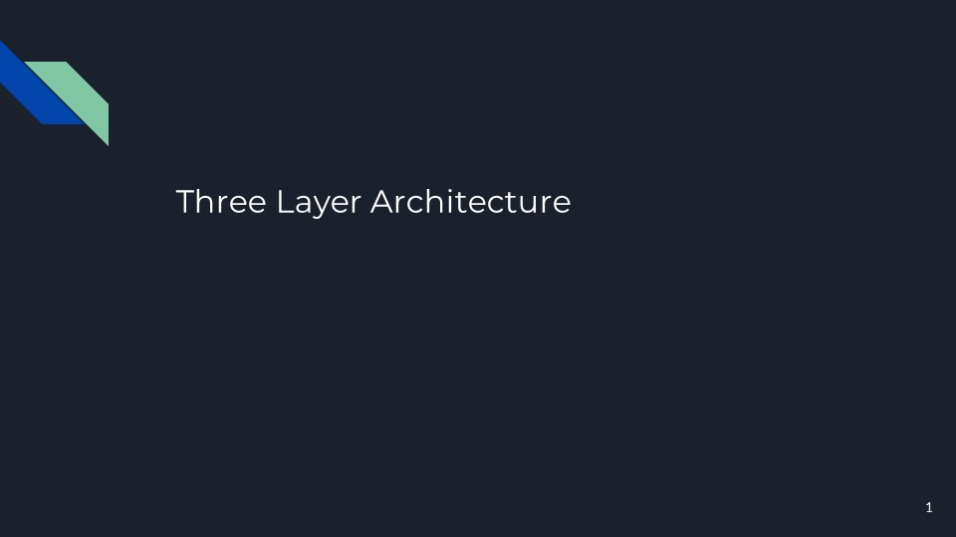

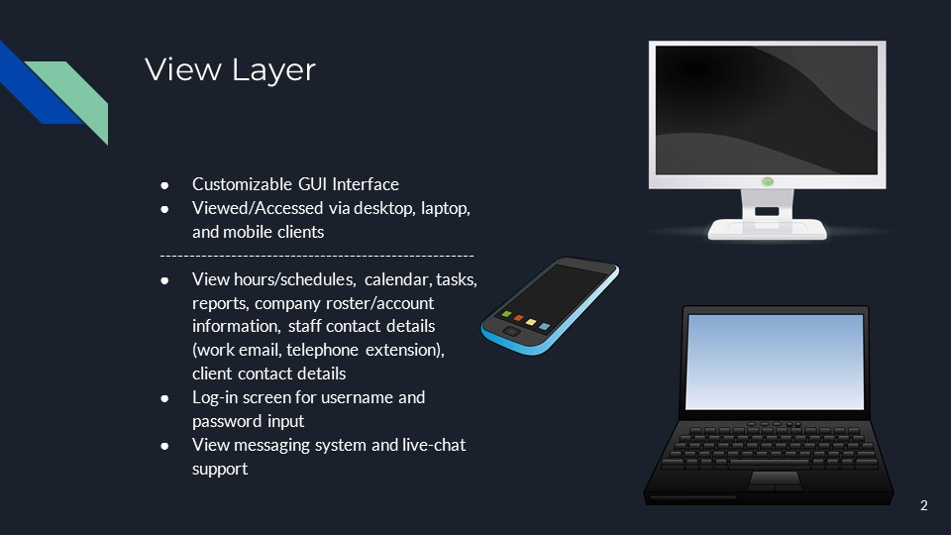

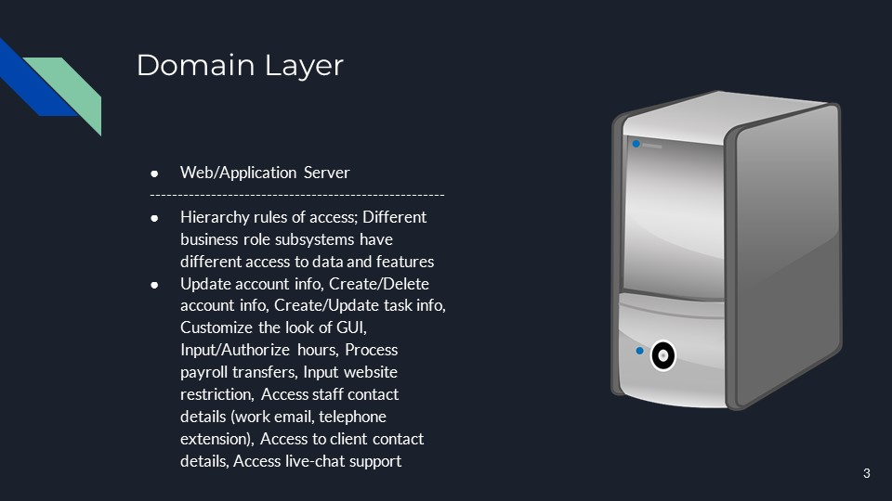

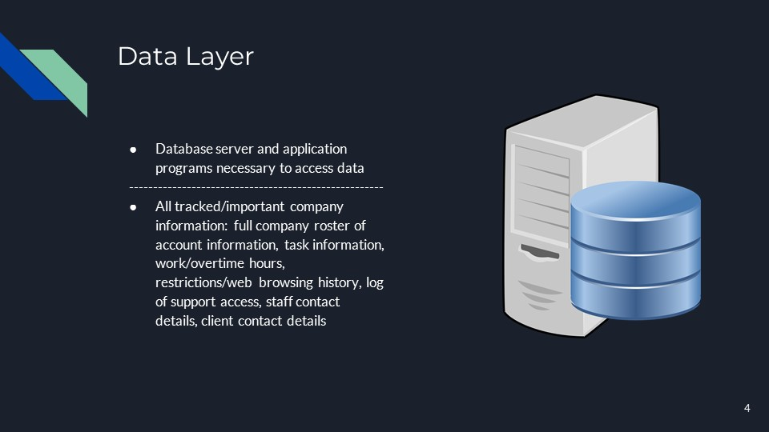

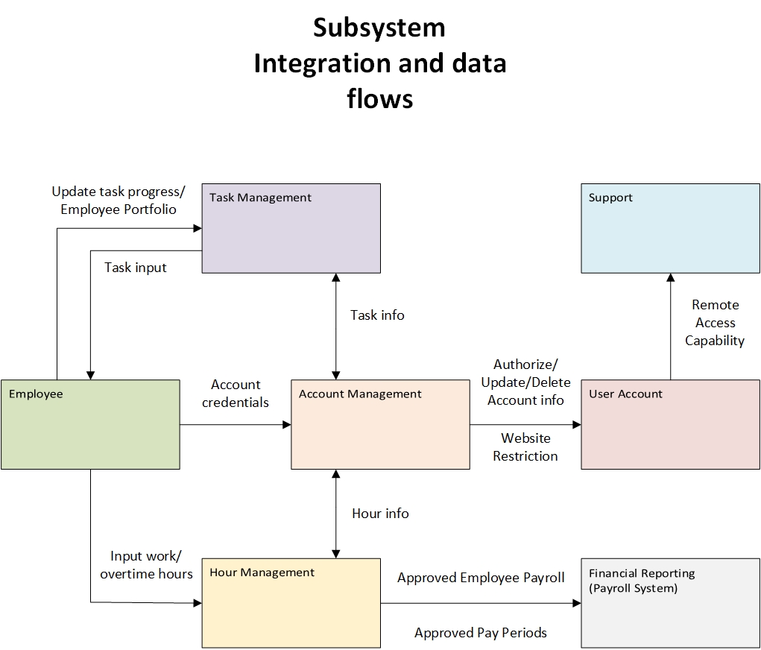

**User Interface Designs**

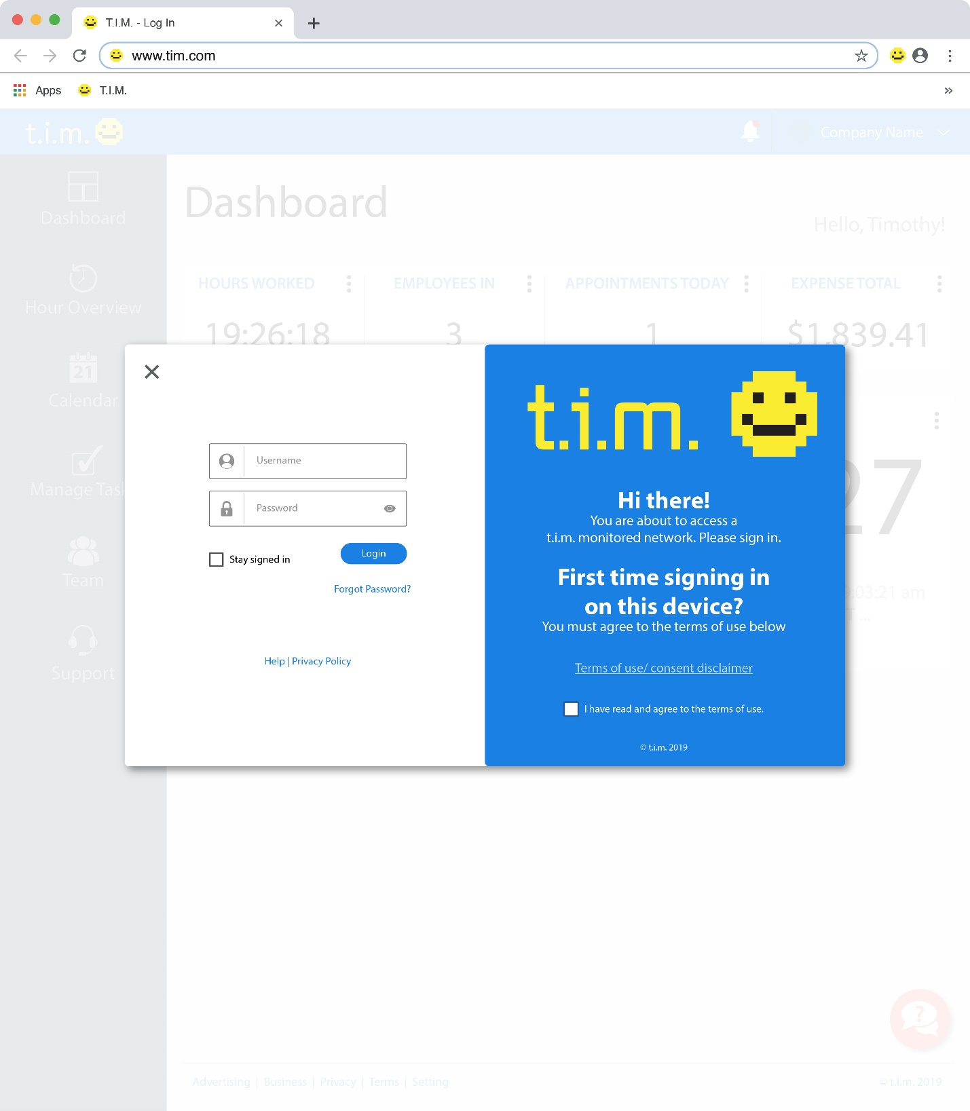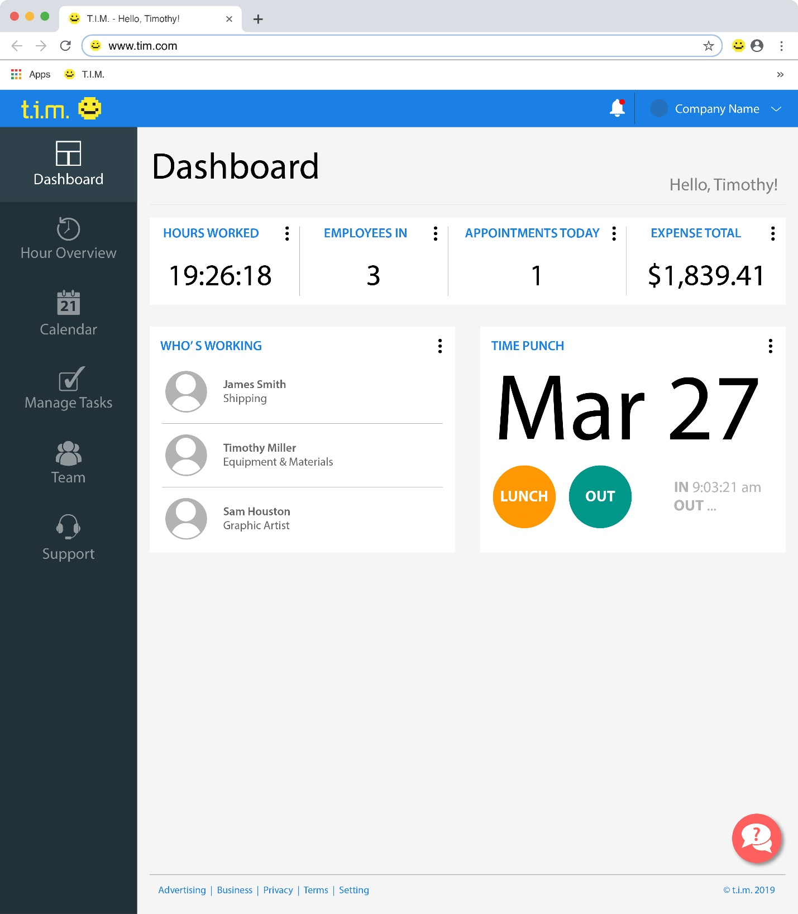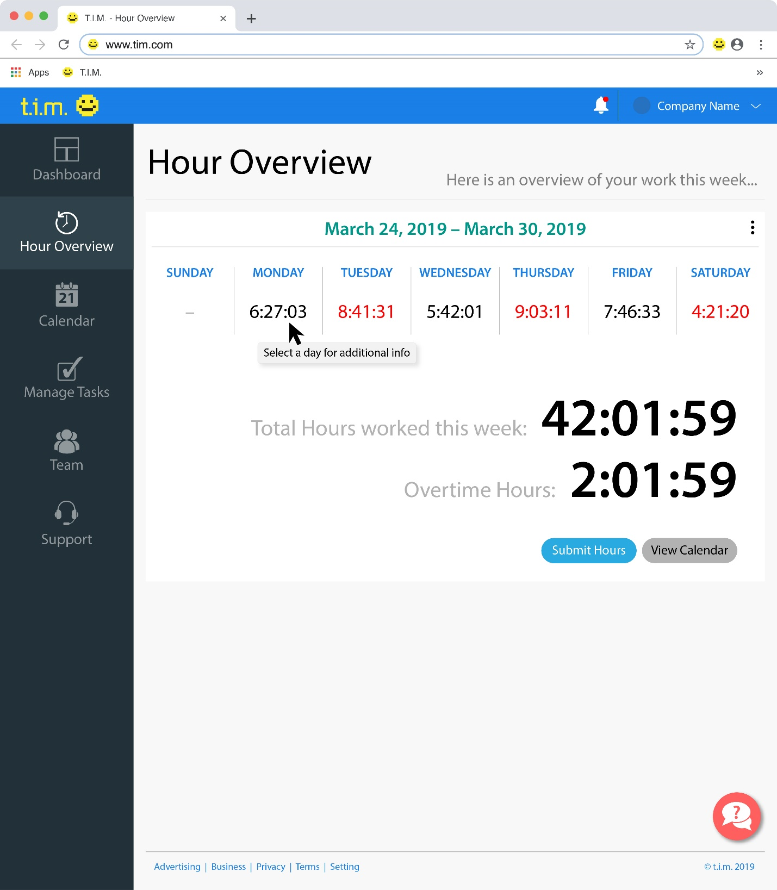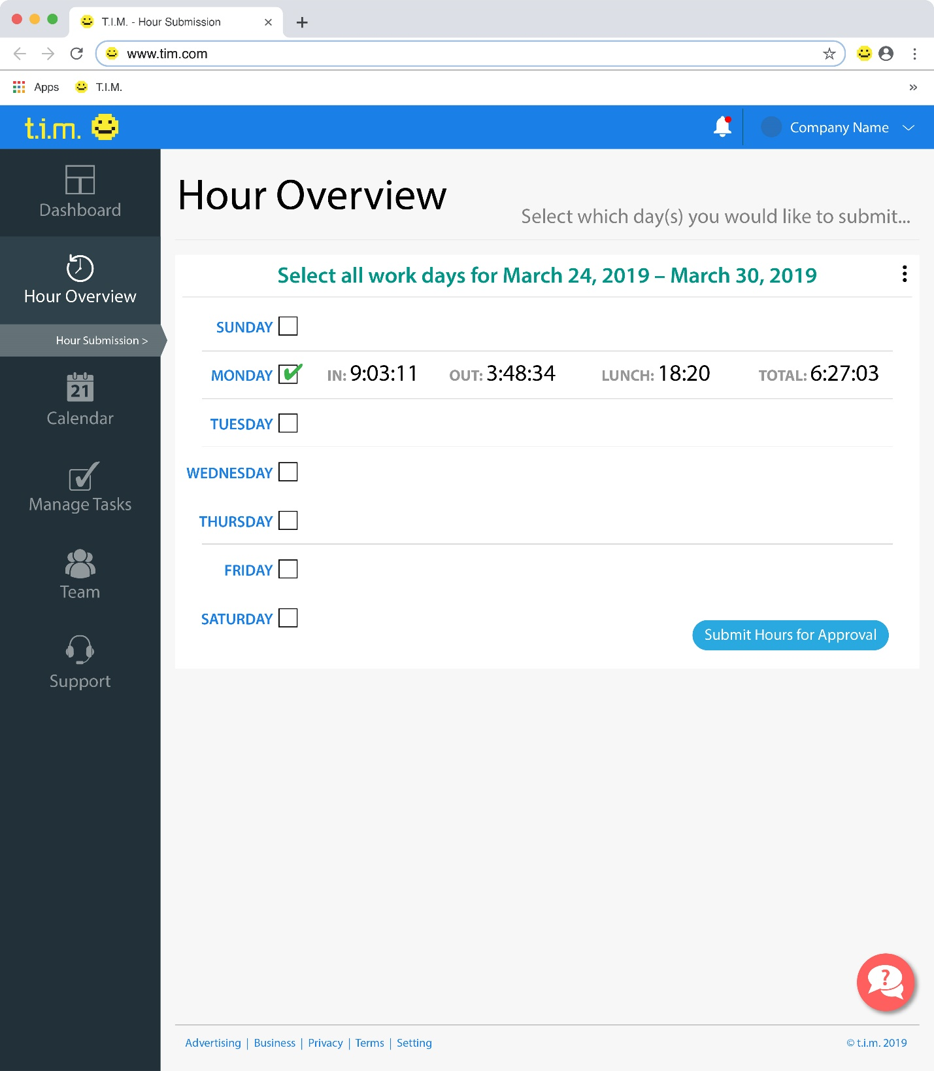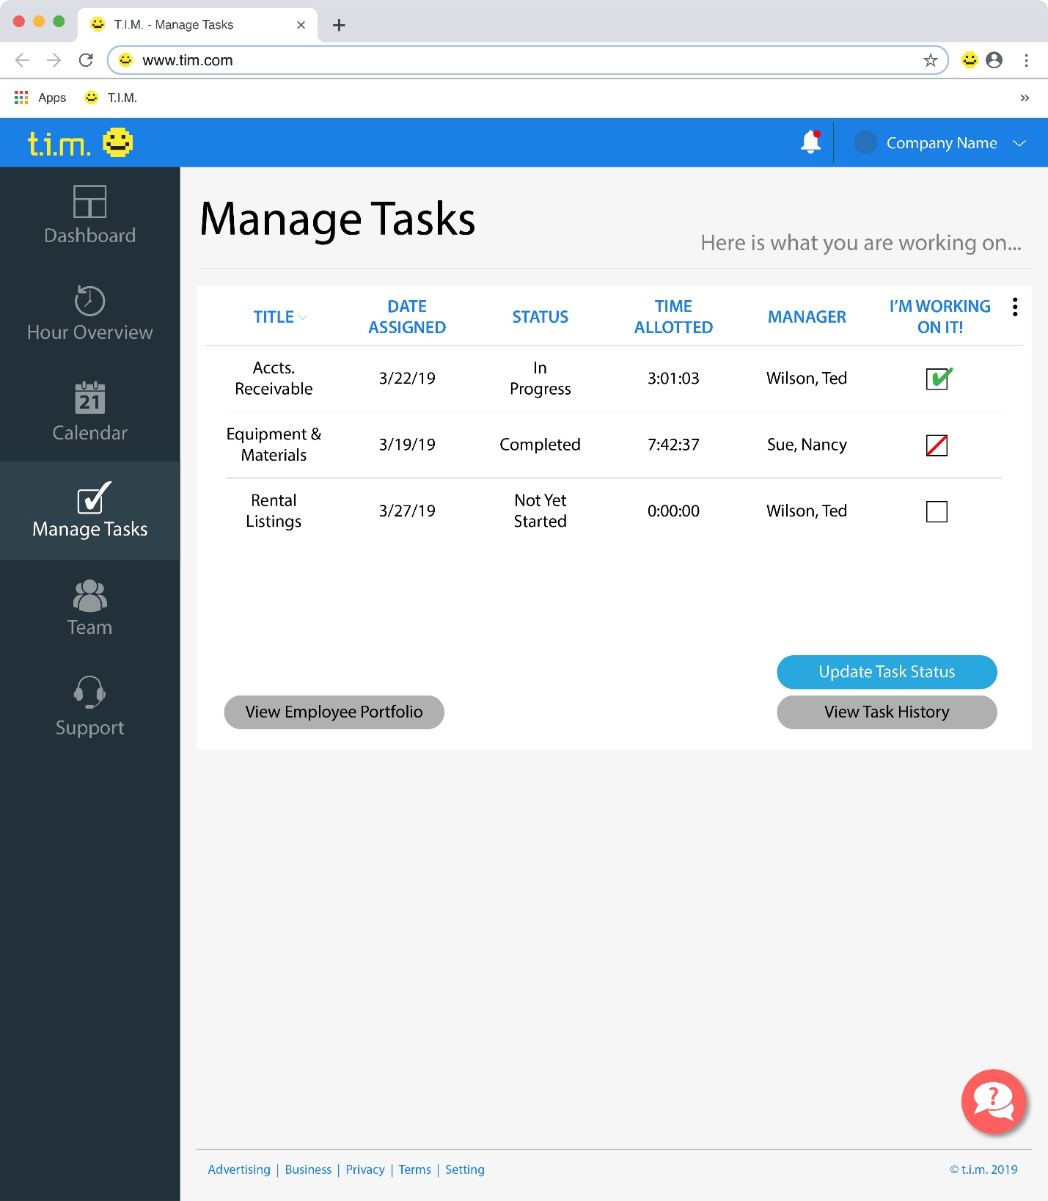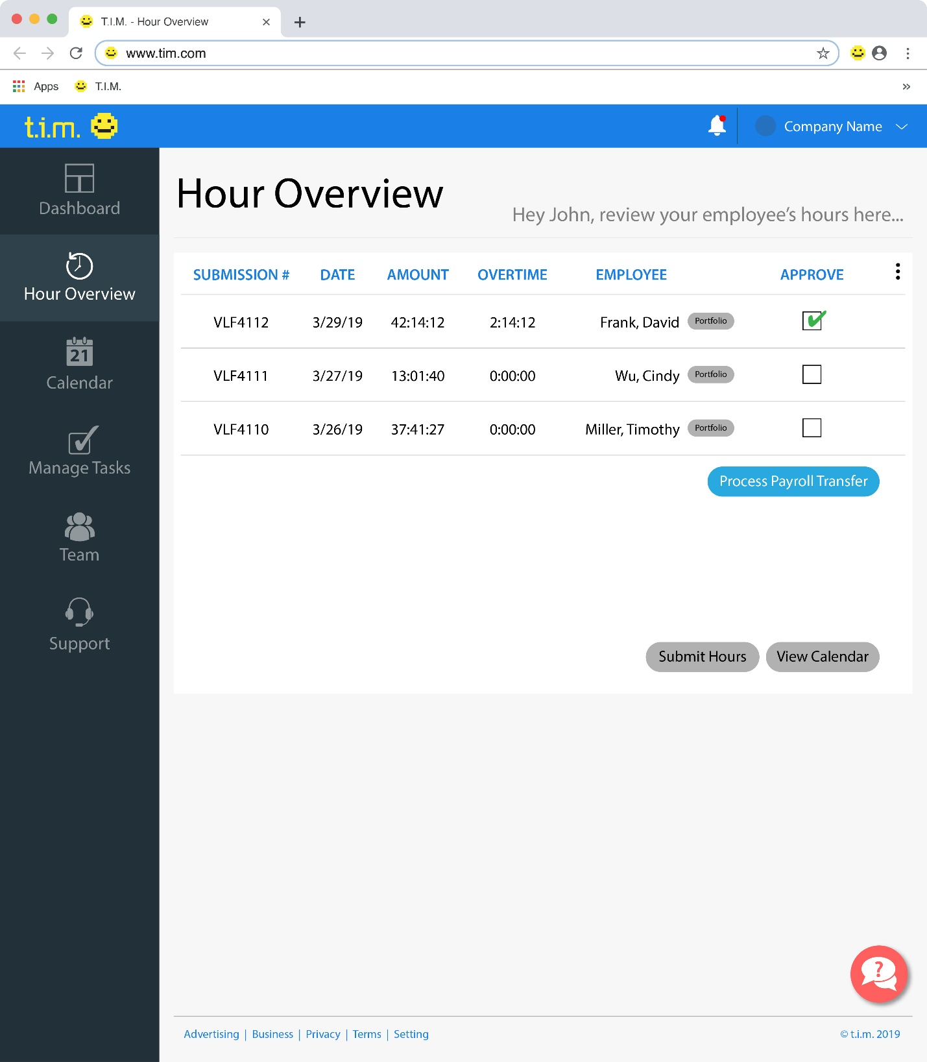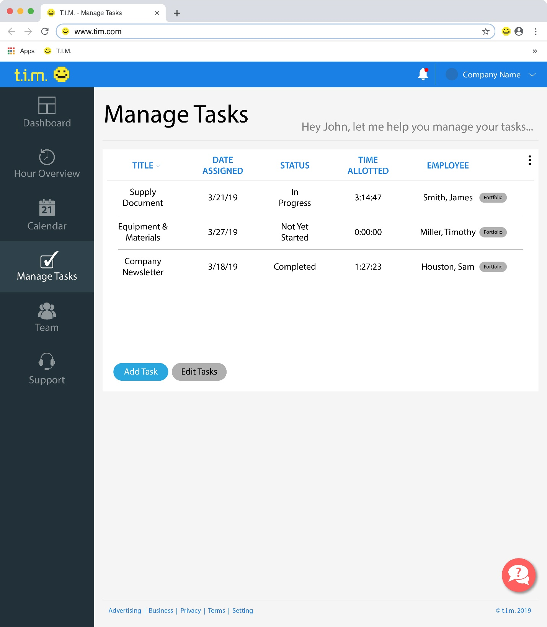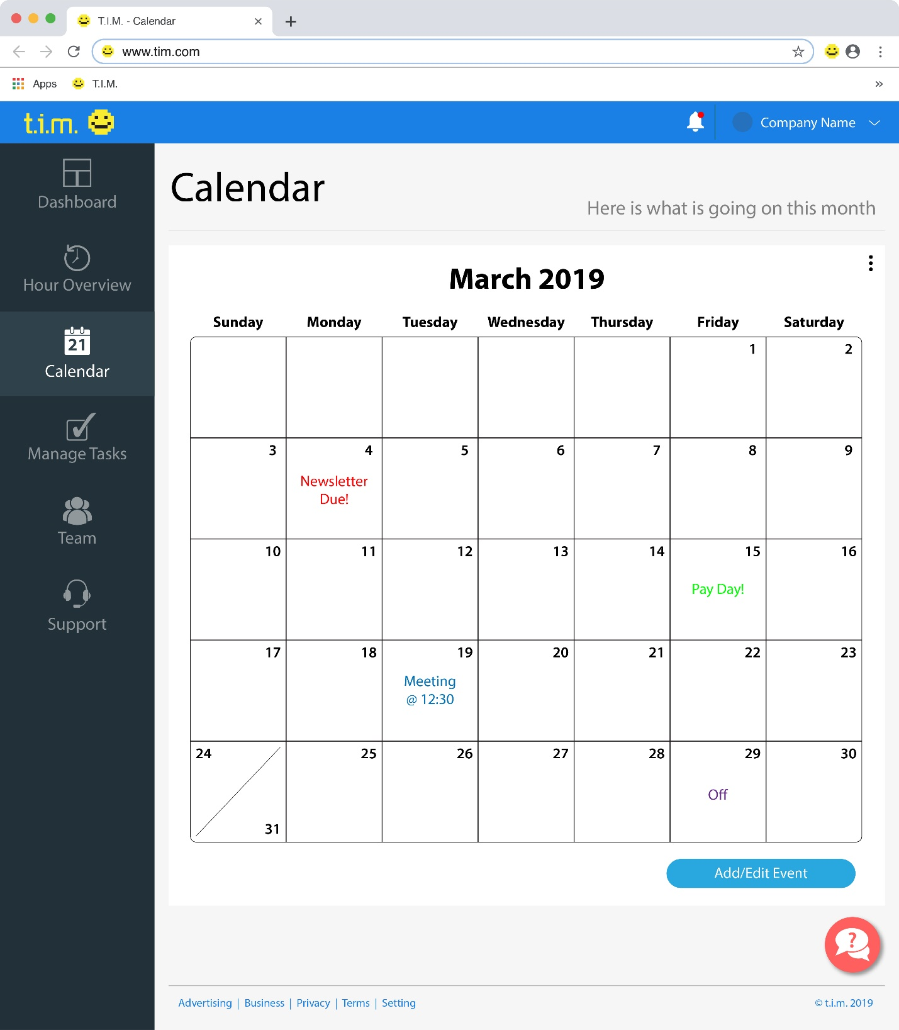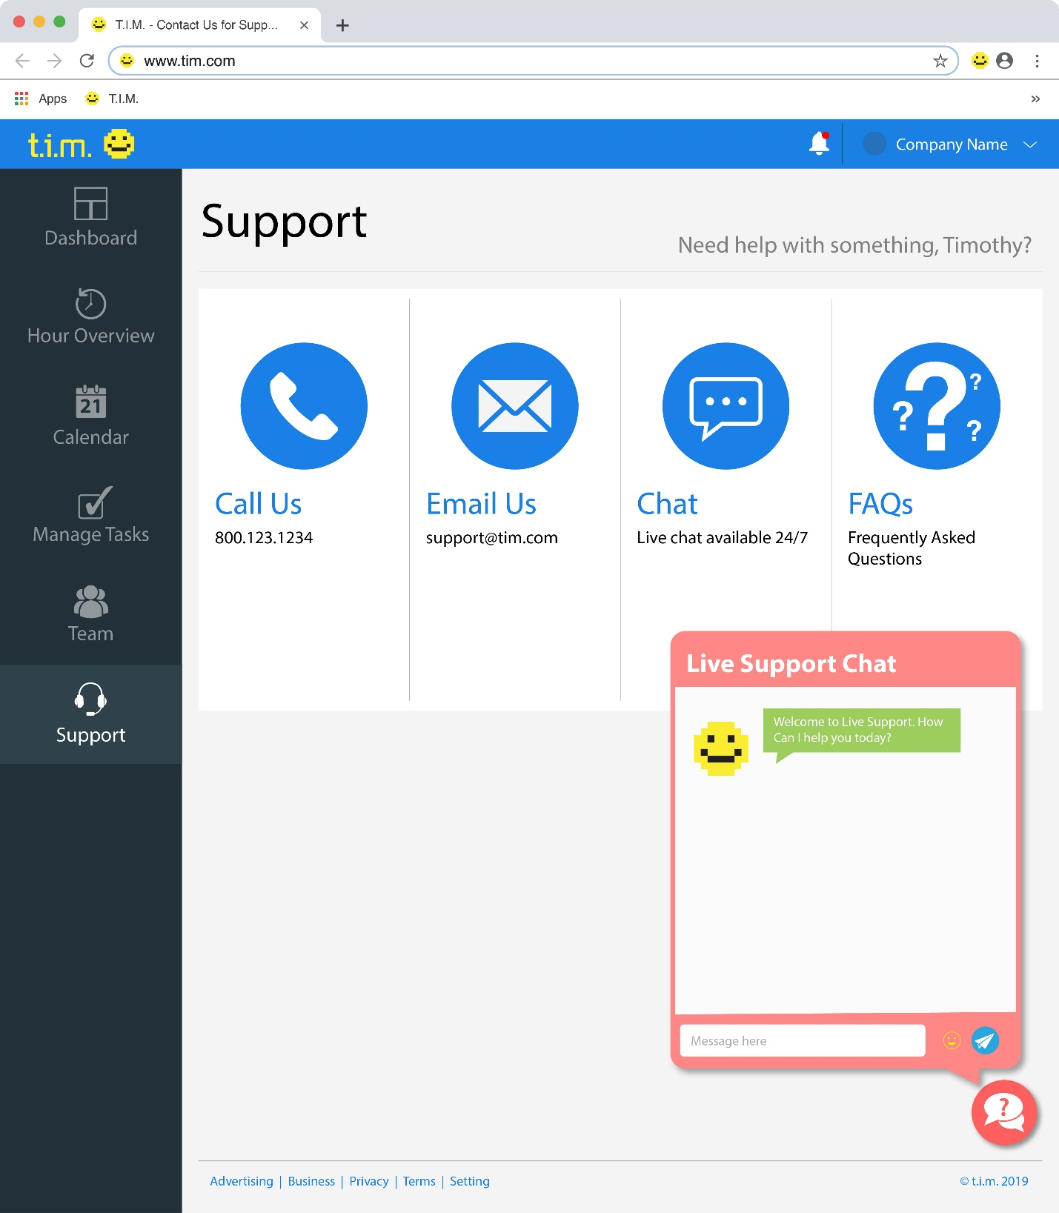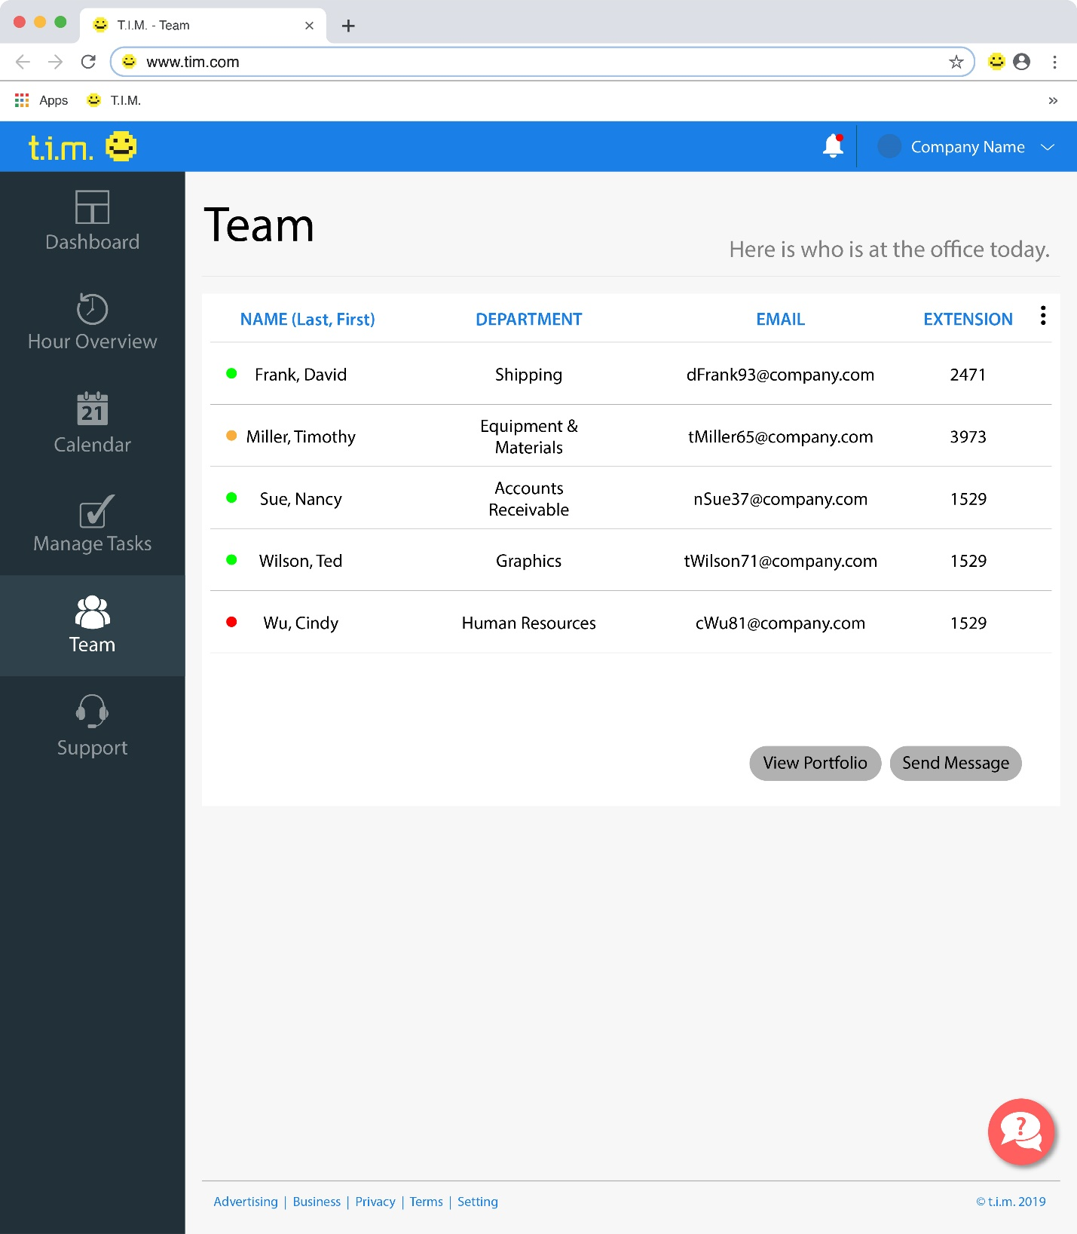

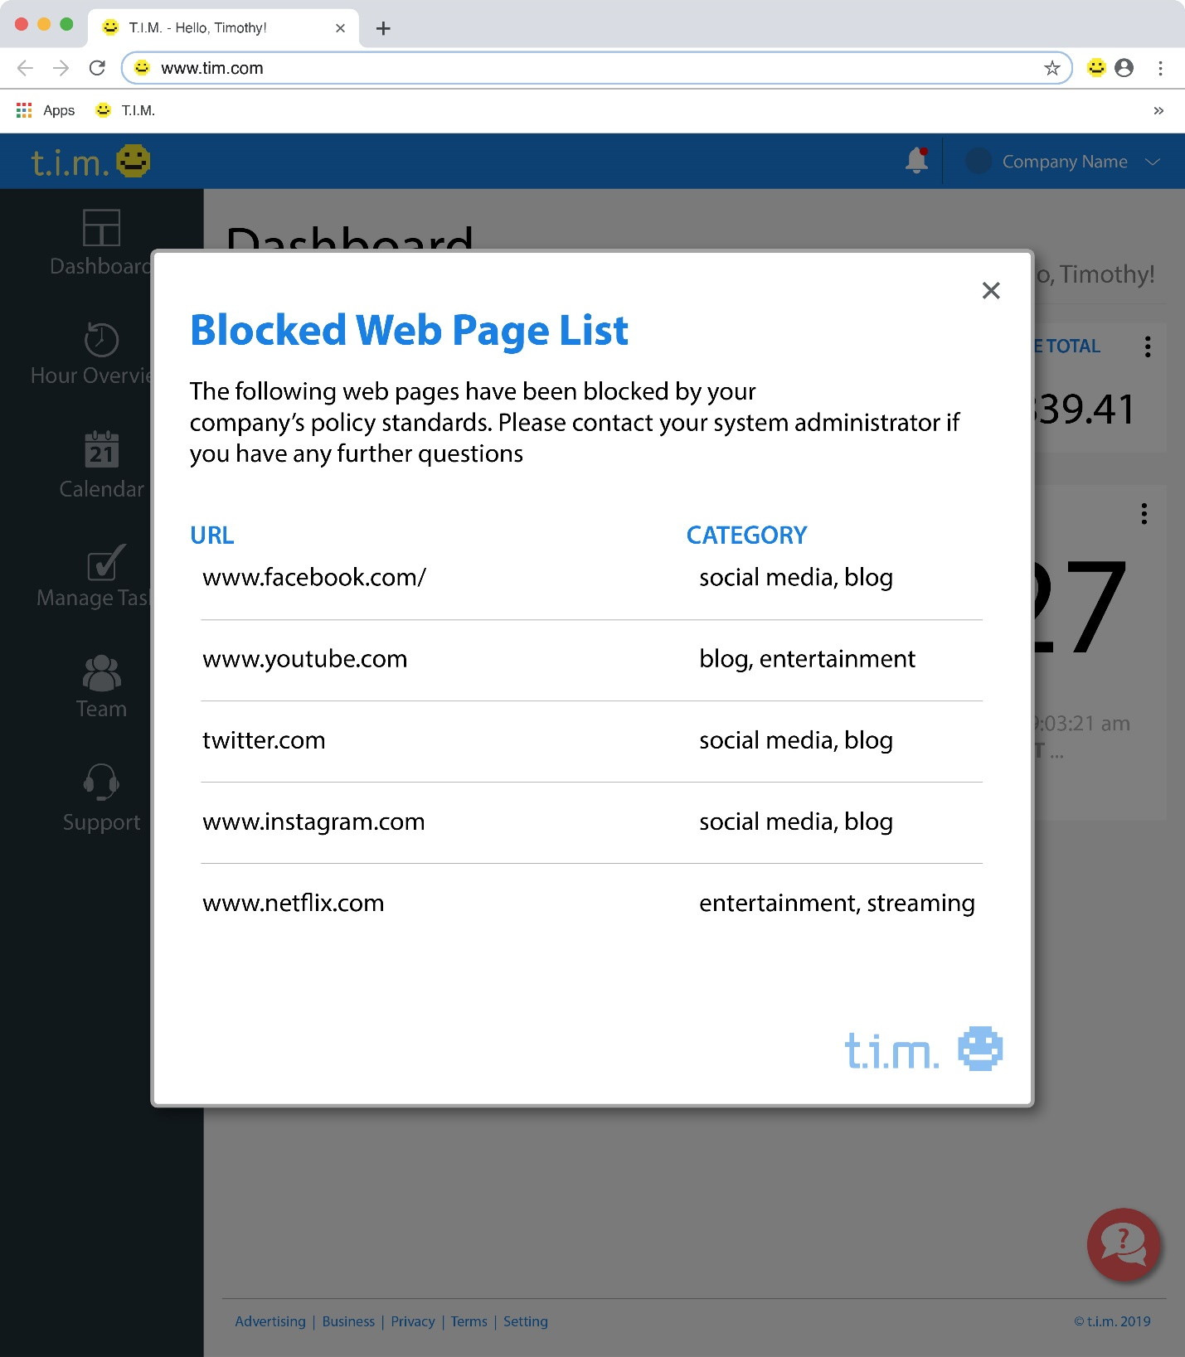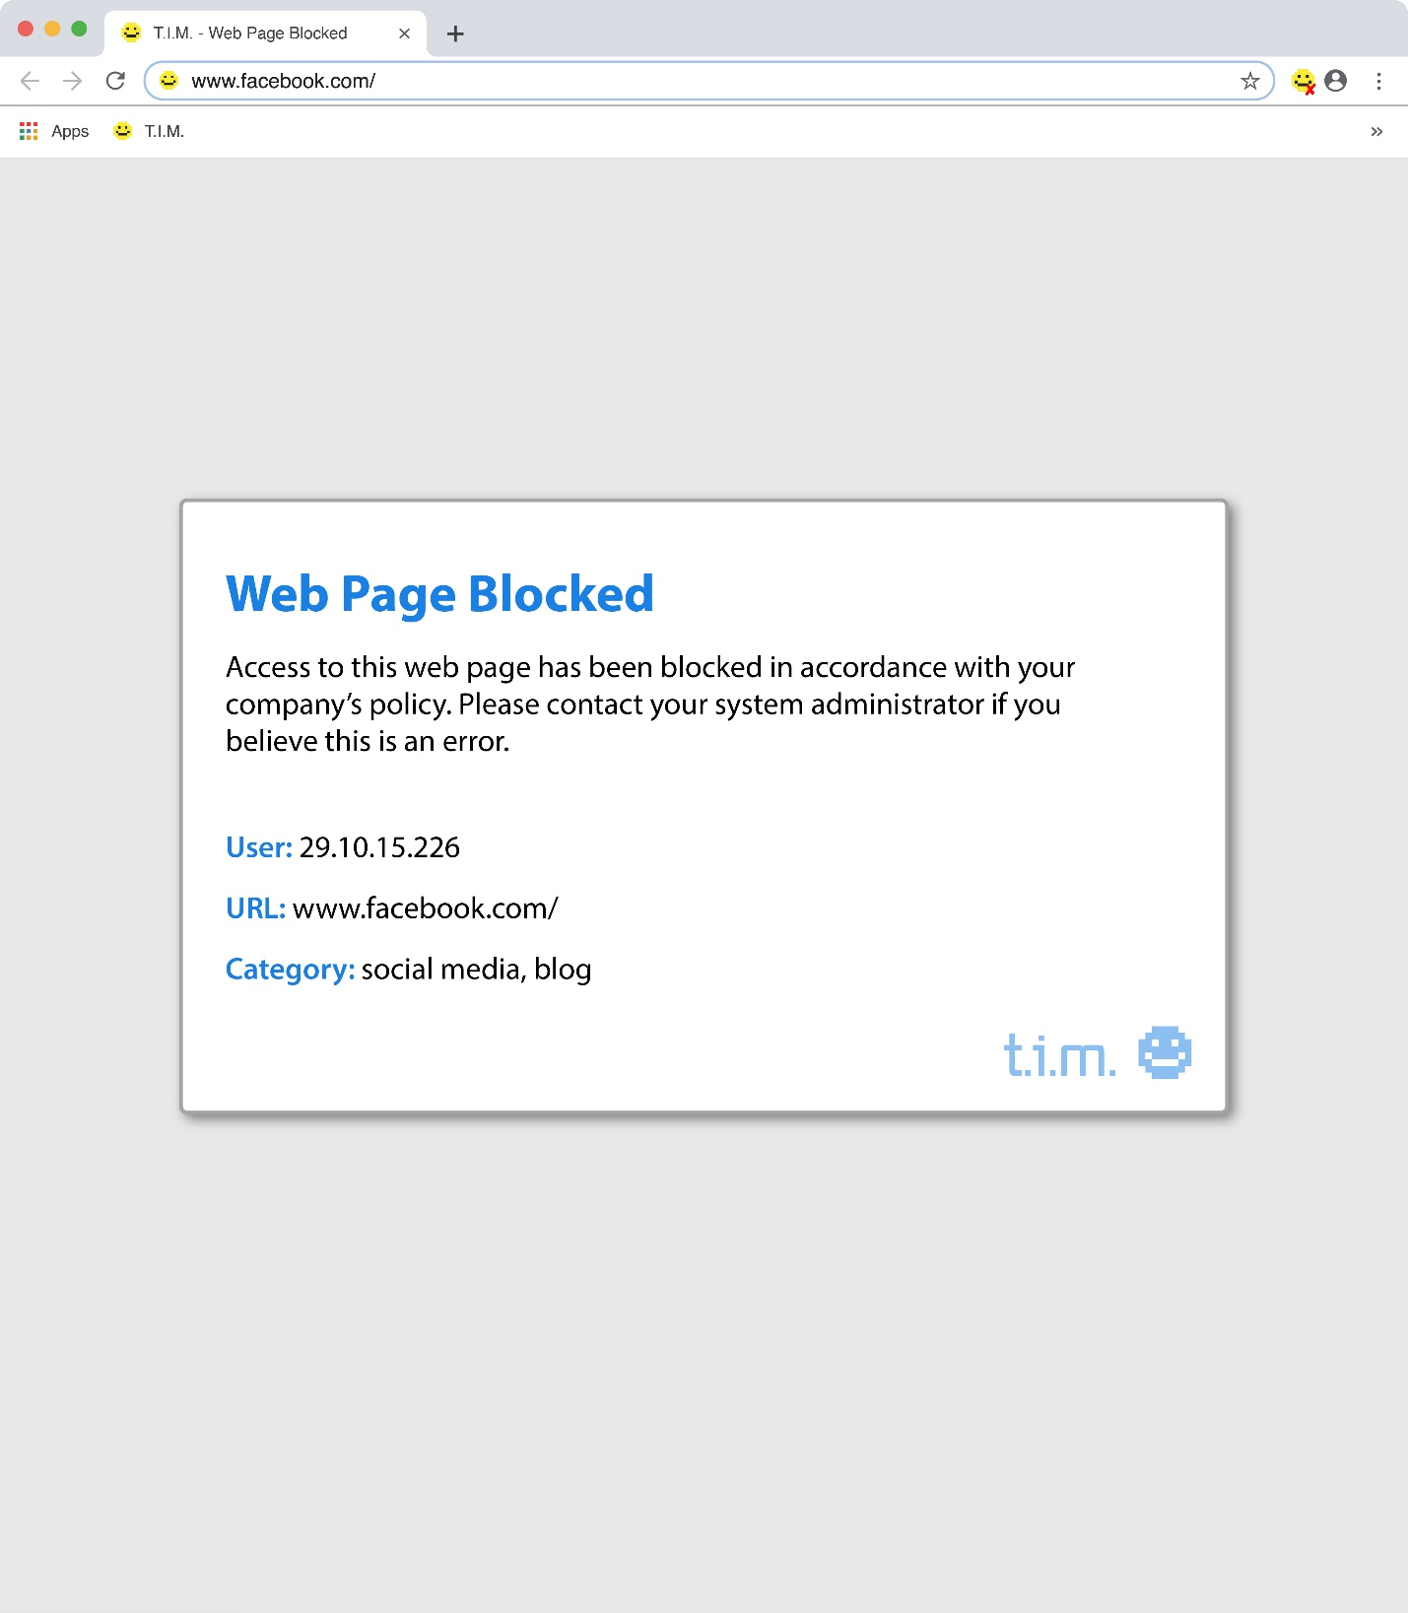

**Database Designs**

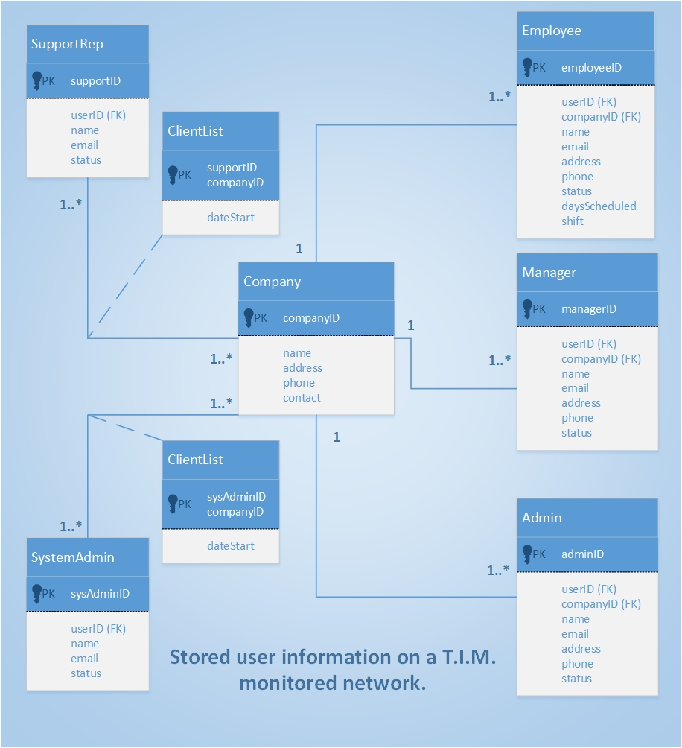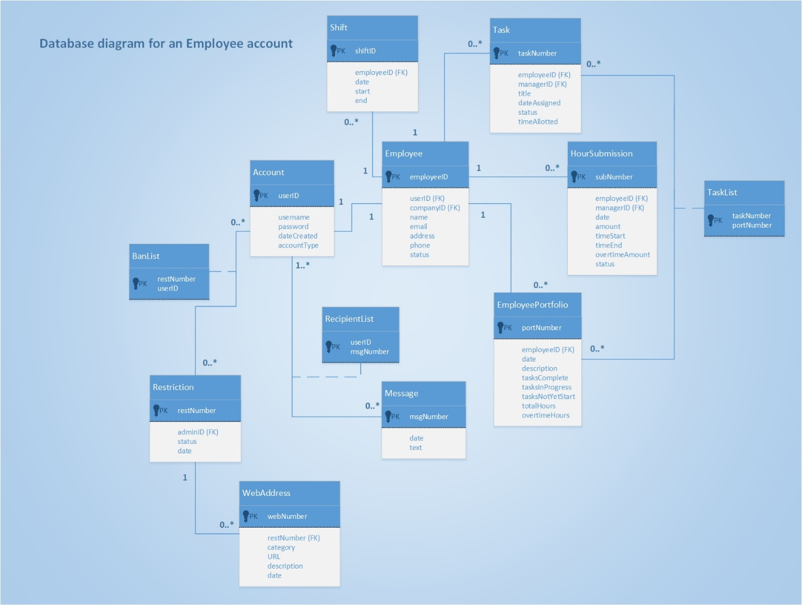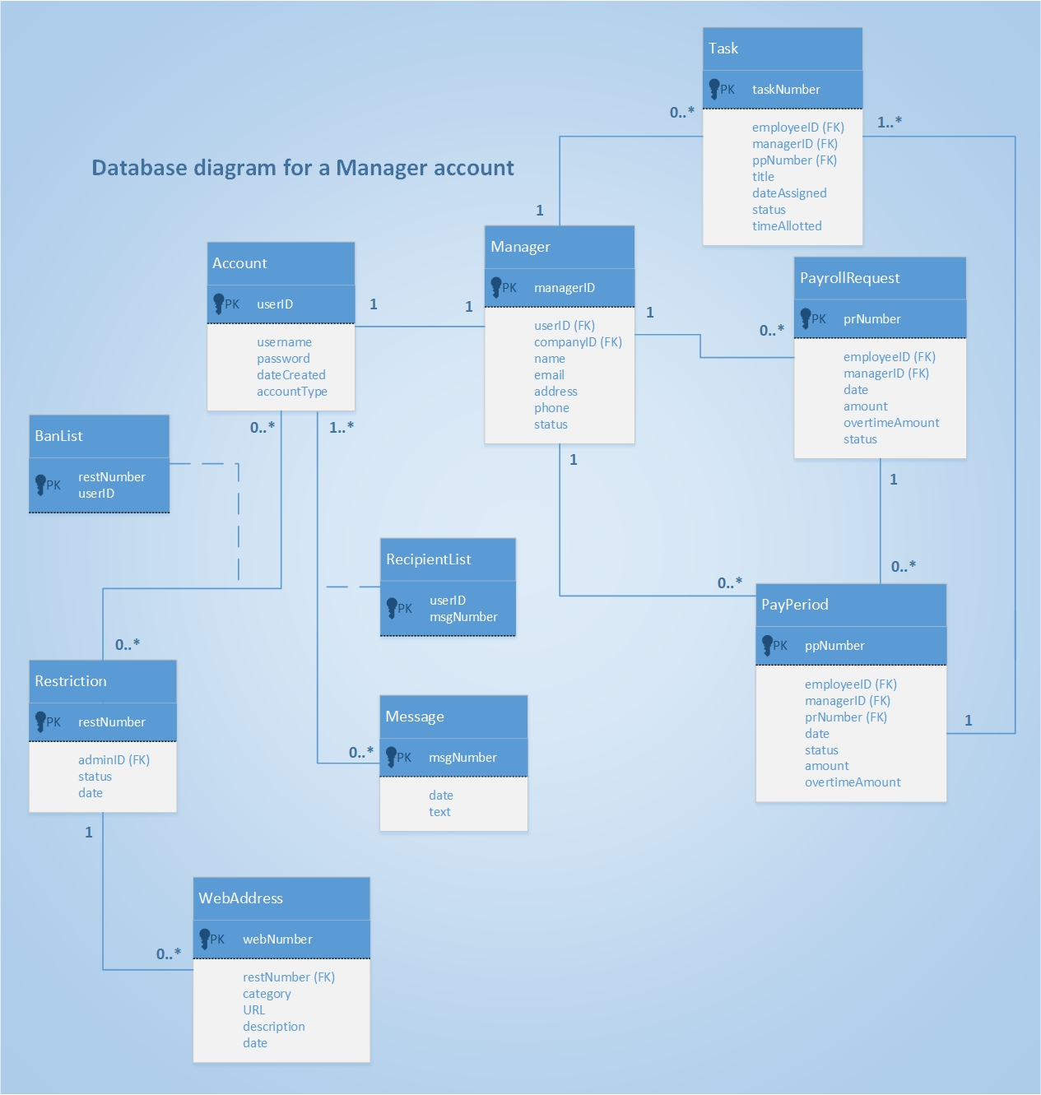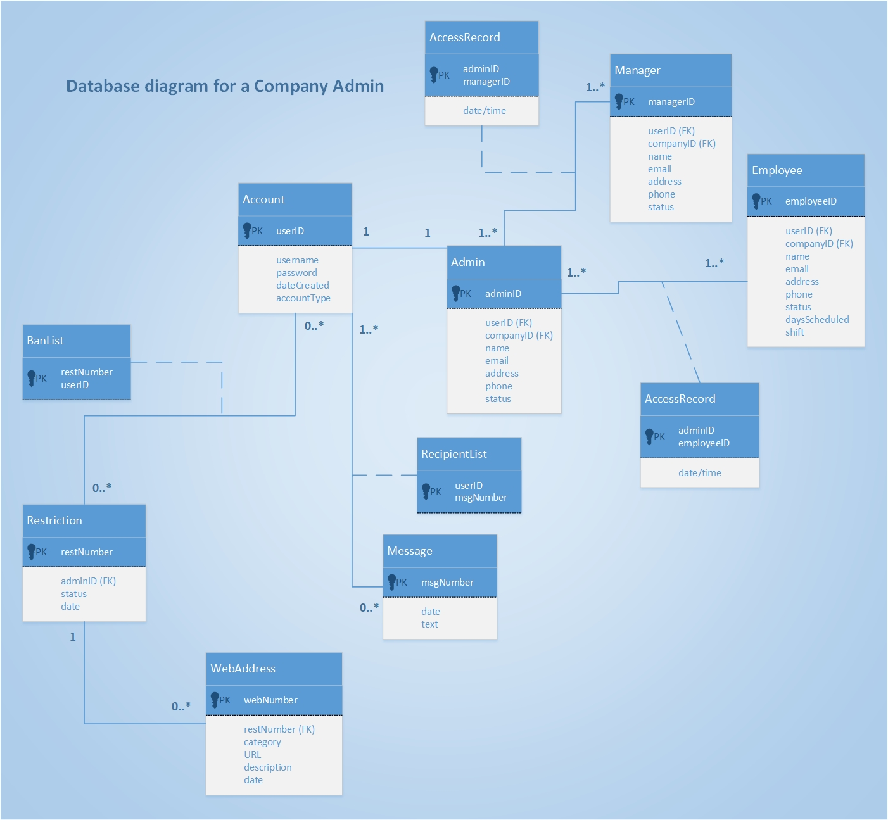



**Work Breakdown Structure**

1. **Project Initiation**

* Develop an Employee Monitoring/Time Management system to optimize workplace productivity.
* Clean, simple, and user friendly

1. **Project Planning**

* Develop WBS. Use as a guideline for scheduling and plan the work.

½ day

**Analysis Team:** Team of 2; Work together in fact-finding, gathering requirements, and generating all diagrams (class diagrams (ERD), model user/system input/output (SSD)).

**Design Team:** Team of 2;Work together to identify the application components, scope/size, and generate architecture diagrams. Break off solo; One member will design the user interface, the other will design the database.

**Development Team:** Team of 4; All members of the analysis and design teams will contribute to programming and testing tasks.

1. **Analysis**

* Meet with business management and employees to gather user case stories and user goals. Identify all acceptance criteria.

1 day

* Define and organize all requirements. Identify possible subsystems.

½ day

* Generate diagrams to identify possible data elements and relationships.

½ day

* Model user/system input and output

½ day

**End of Week 1 (Milestone 1):** Share analysis with design team.

1. **Design**

* Identify the application components, scope/size, program classes and methods, ensure system security/asset control, and develop architecture diagrams.

2 days

* Design screen layouts of the user-interface.

3 days

* Design the database schema (Verify with analysis team all required data elements are included)

2 days

**End of Week 2 (Milestone 2):** System is ready to be implemented.

1. **Implementation**

* Build database (Verify with all team members)

1 day

* Design classes (object-oriented) and implement program code for user-interface. Integrate user-interface with database.

6 days

**End of Week 3:** System is ready to be tested.

1. **Deployment**

* Build test data; Unit testing, integration testing, full system testing, and stress testing.

4 days

* Perform user acceptance tests.

2 days

* Train users (End users and system operators)

1 day

**End of Week 4 (Milestone 3):** Release accepted version of the system. Initiate support activities as well as monitor the system.(Maintain, enhance, support).

**Design Class Diagrams**

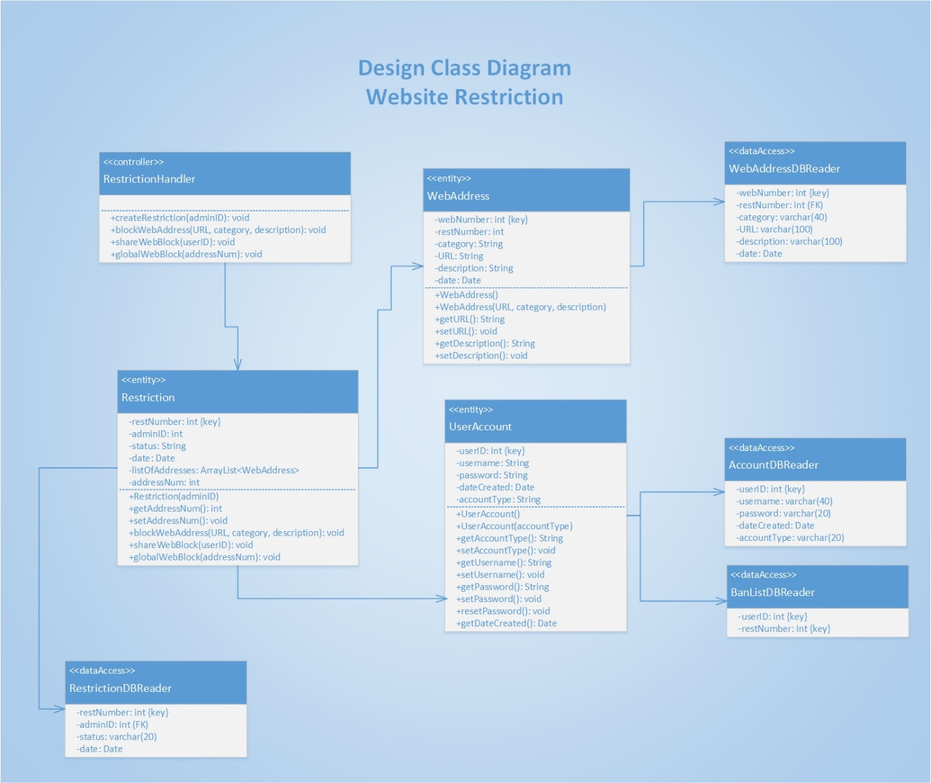

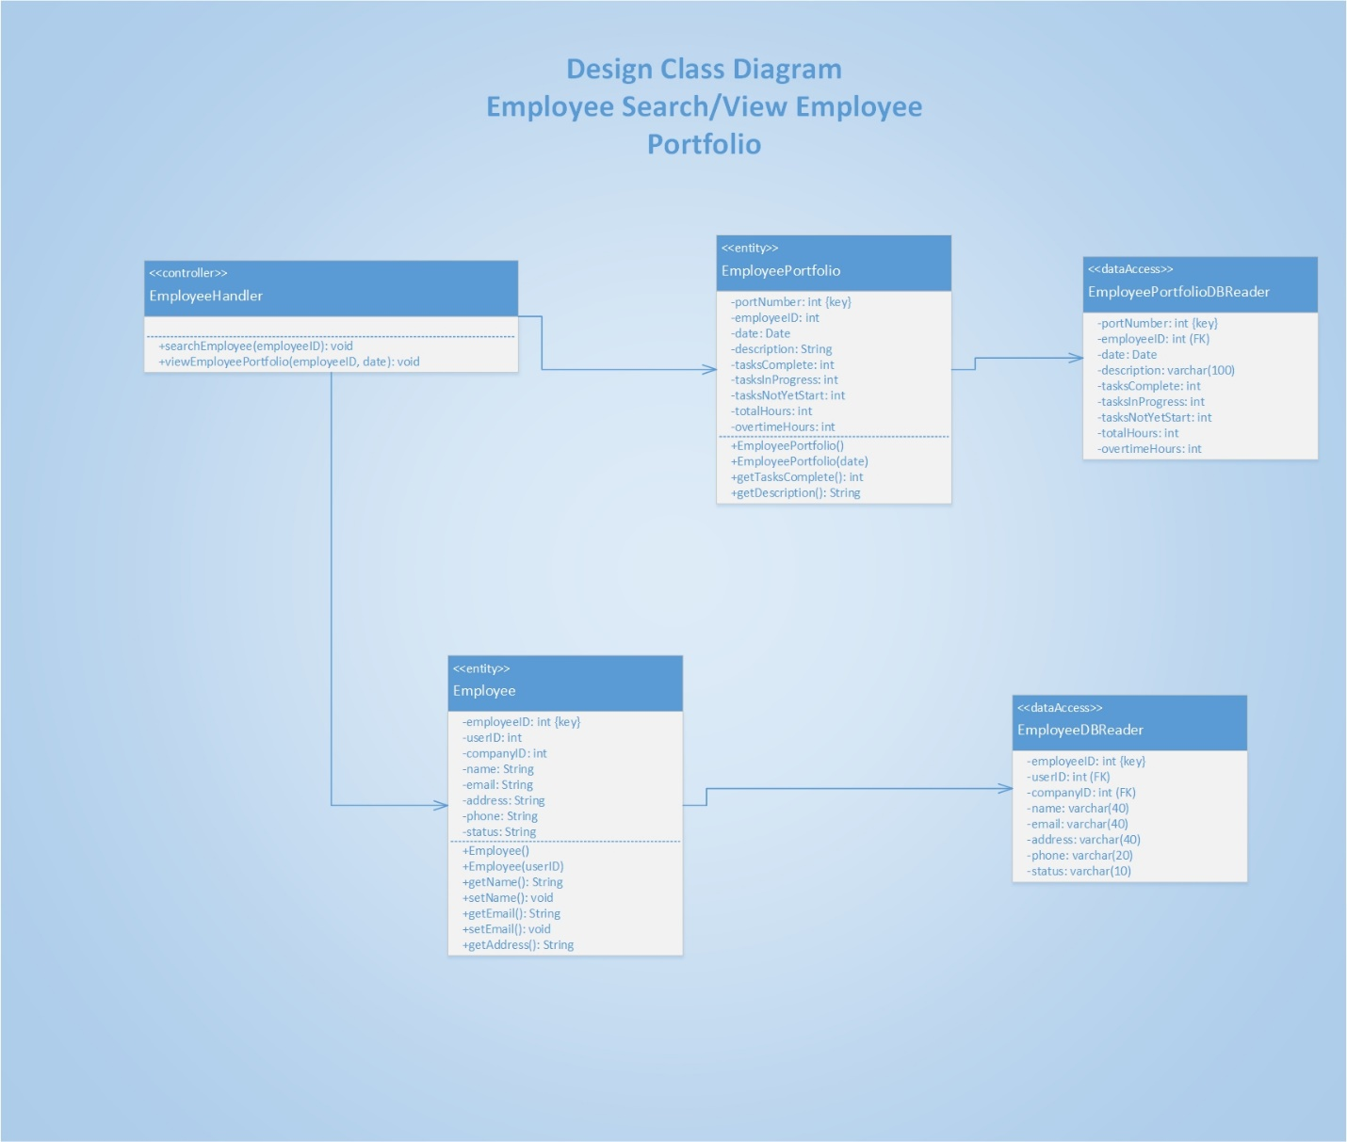

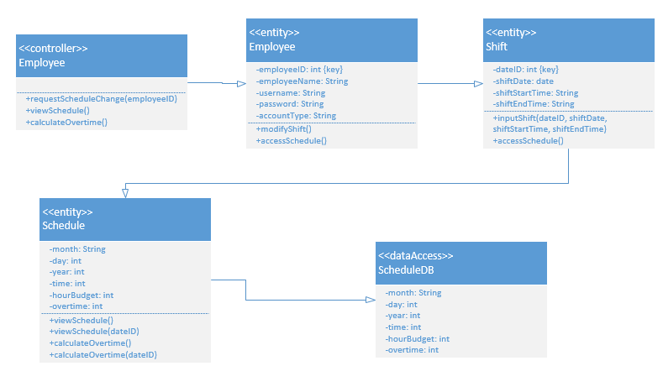

Design Class Diagram

Employee Modify Shift Request/View Schedule/Calculate Overtime

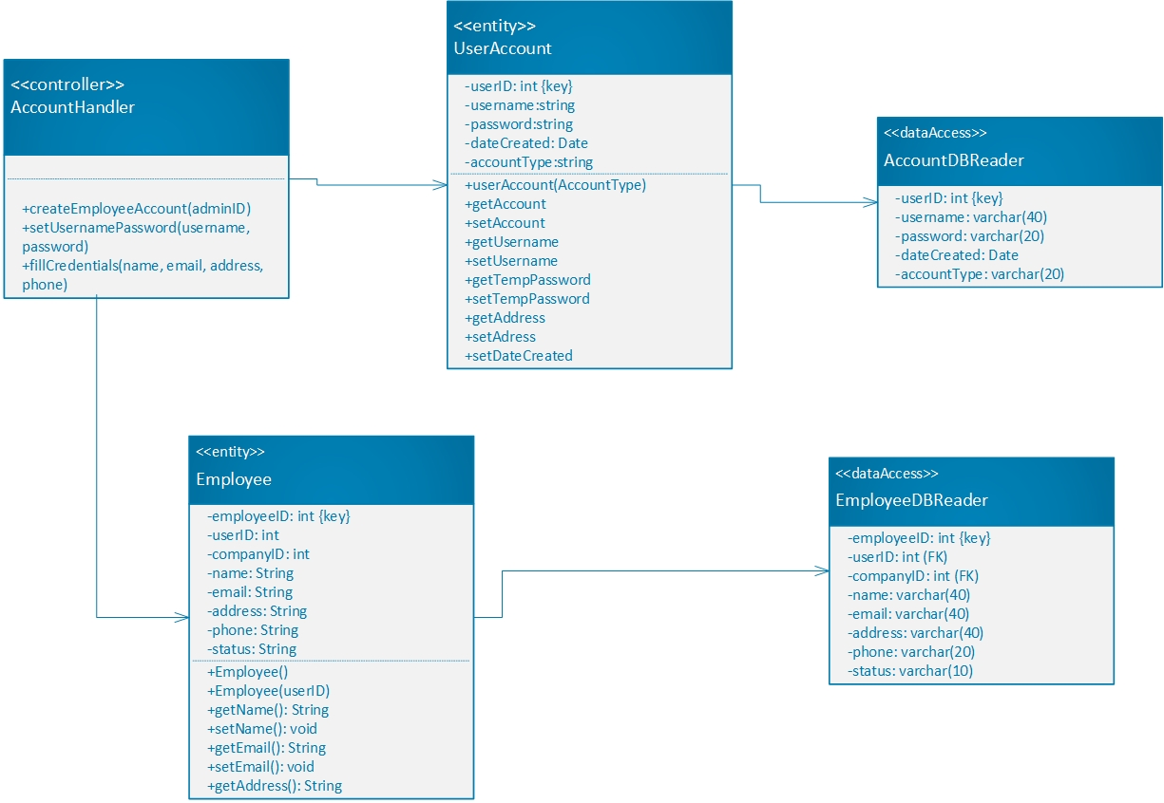

Design Class Diagram

Create Employee Account

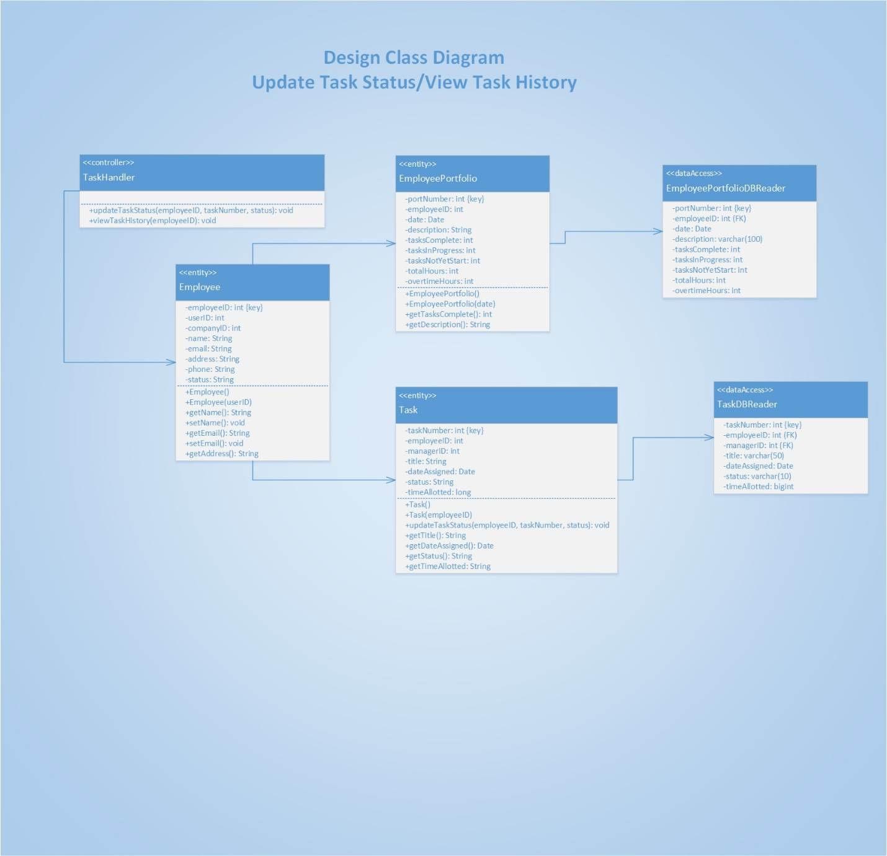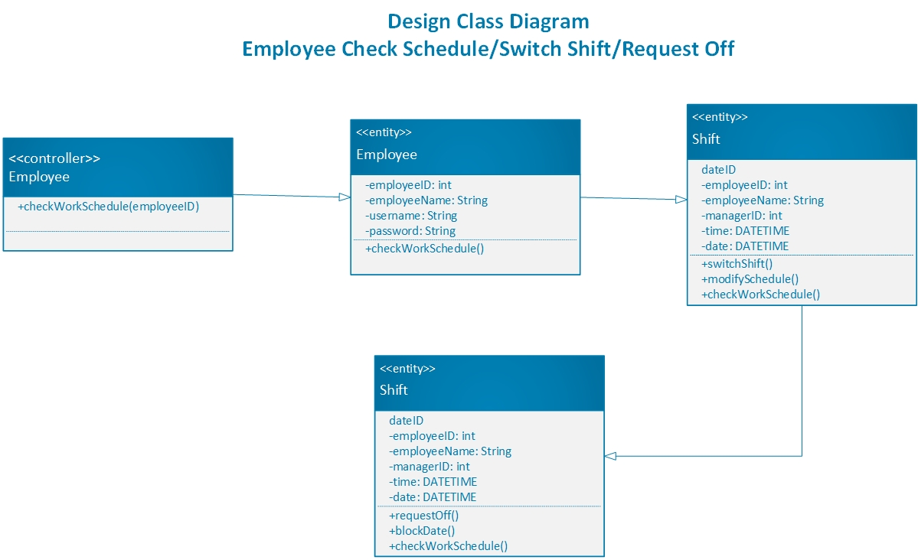

**Sequence Diagrams**

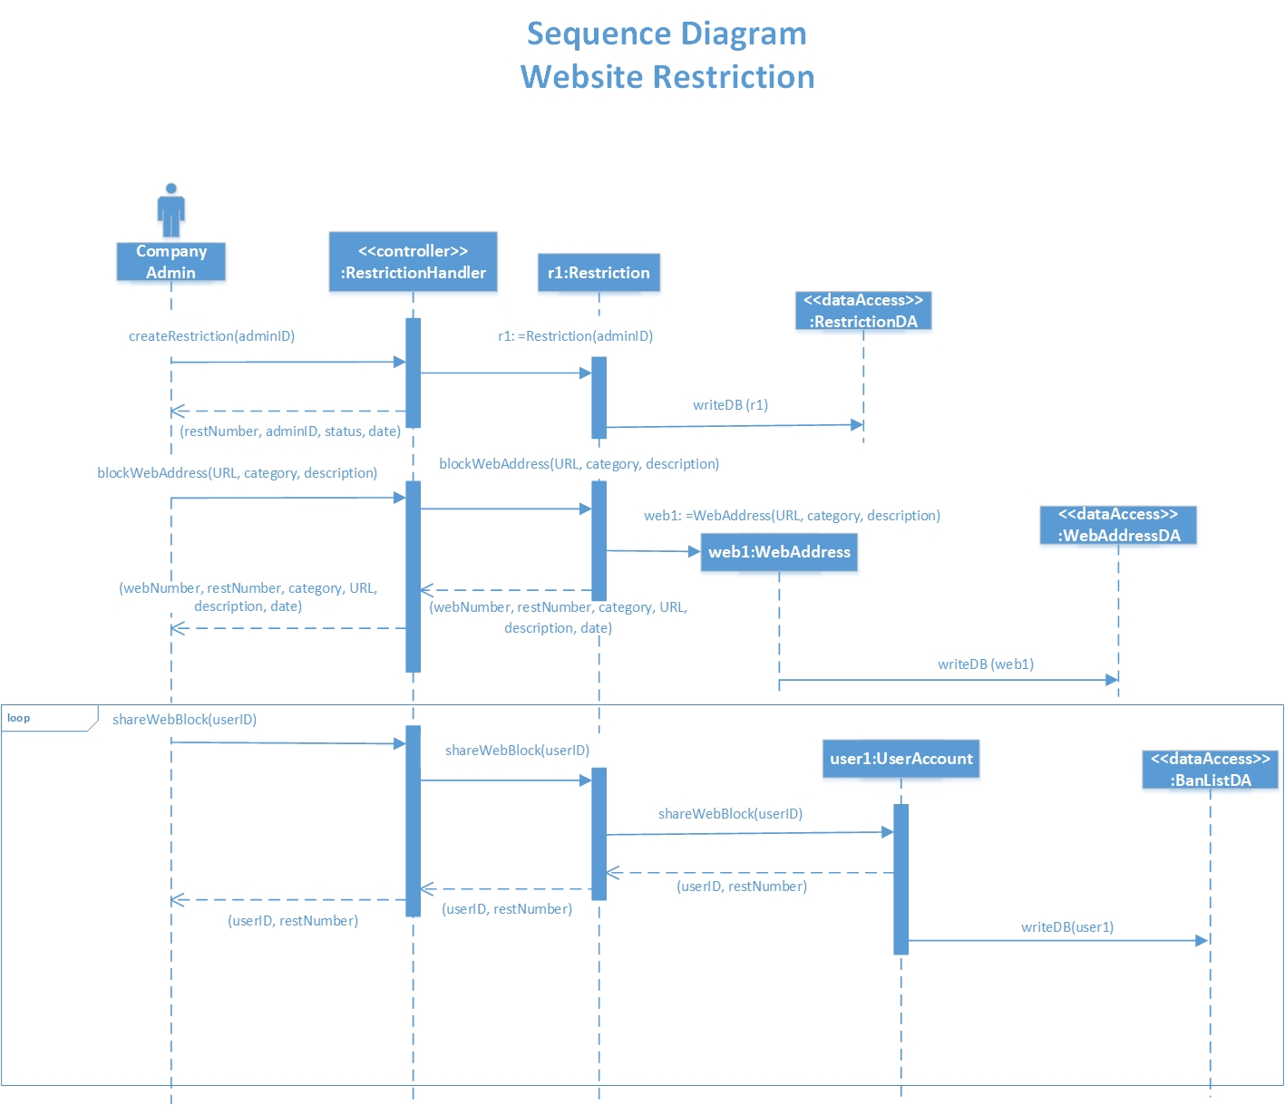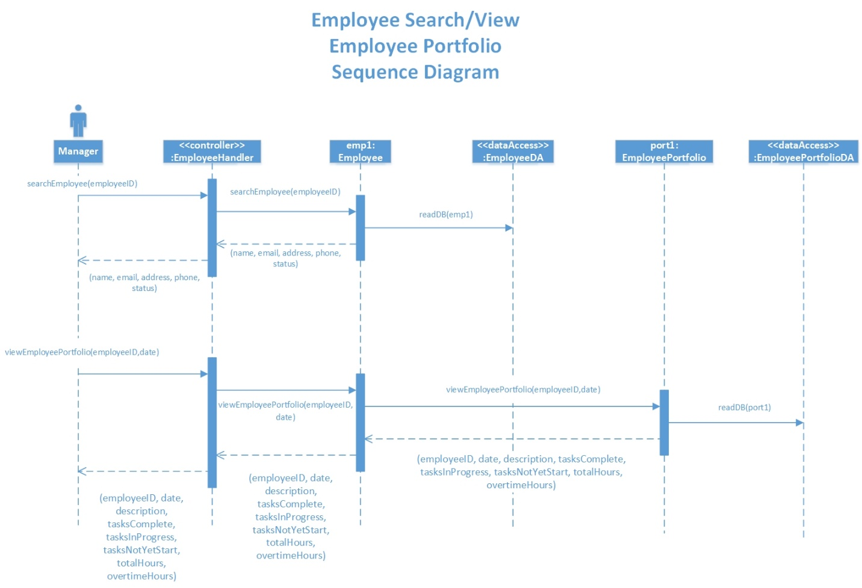

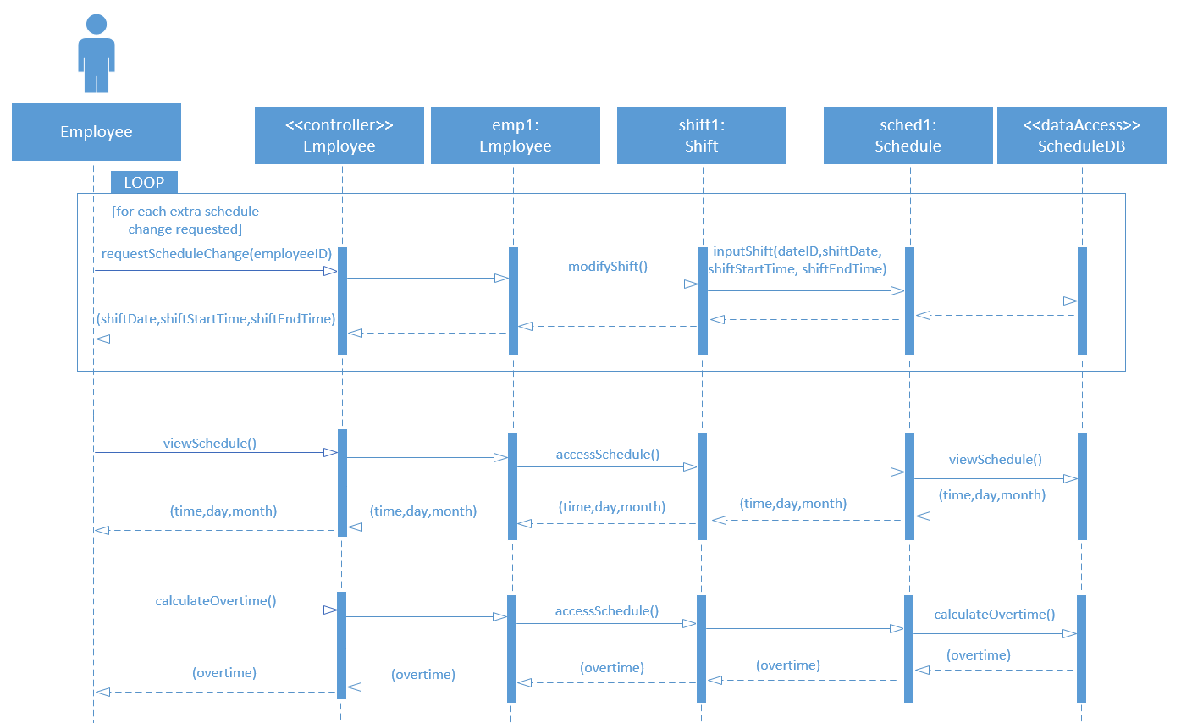

Sequence Diagram

Employee Modify Shift Request/View Schedule/Calculate Overtime

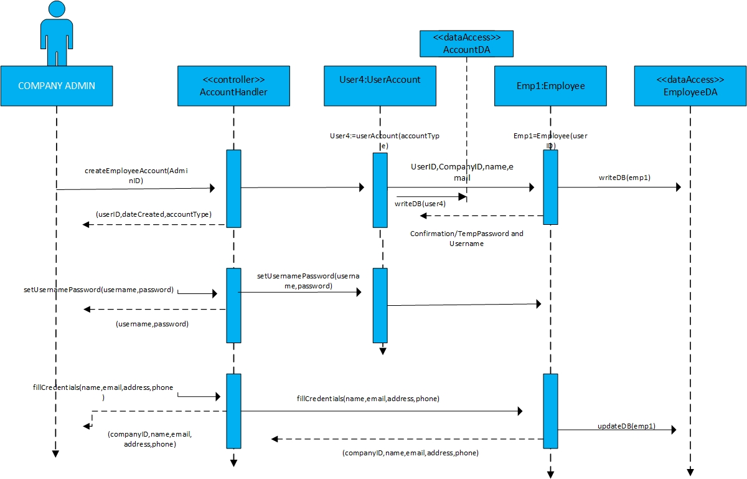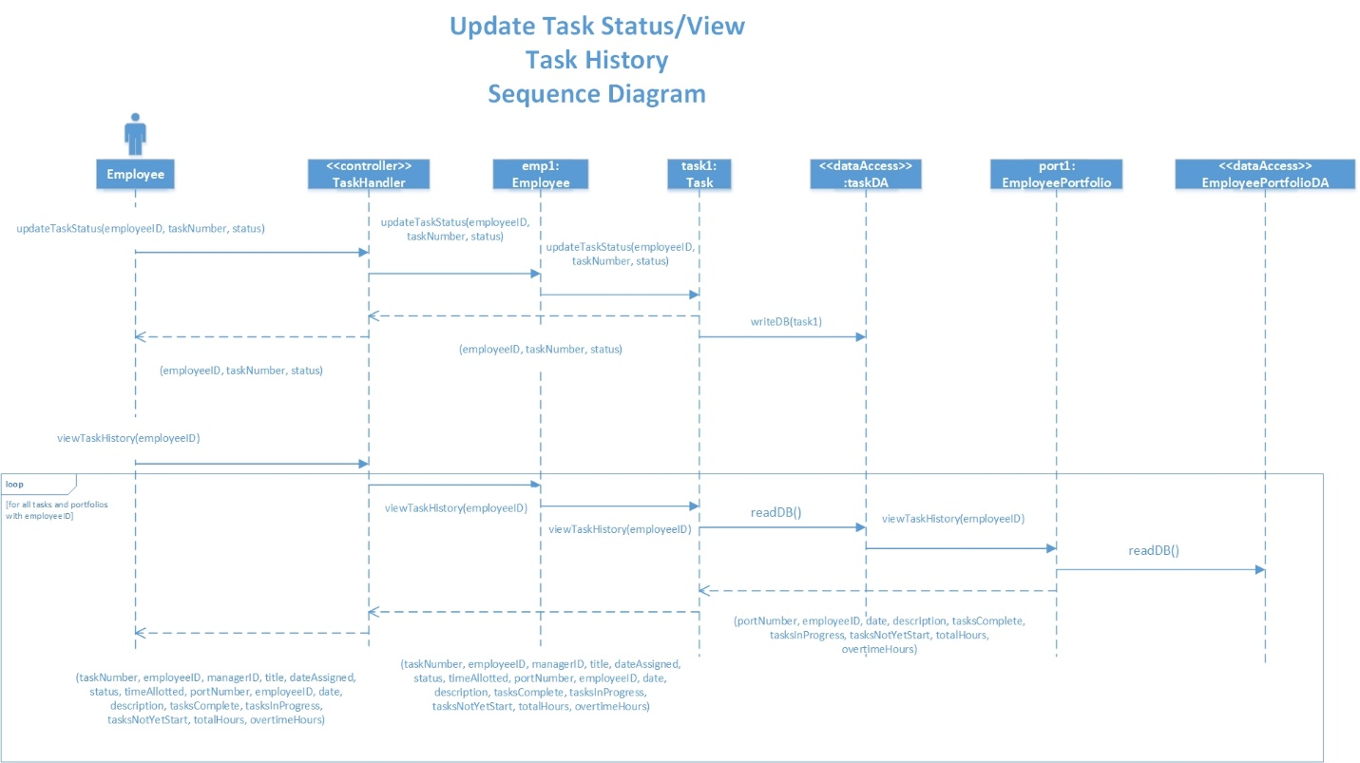

Sequence Diagram

Create Employee Account

